Kelly McGeough
[Company name] [Company address]
Getting started guide

Get to know Kashflow Payroll

Contents
Introduction 2
Security 2
Creating a Kashflow Payroll Account 3
Creating your Kashflow Payroll Account 3
Kashflow Payroll Layout 5
Company and Employee Selection 5
Adding a new company 8
Commercial Information 8
Government Settings 8
Payment Options 9
Payroll Control 9
GP Settings 10
Opening Balances 11
Payments & Receipts 11
Departments 11
Job Titles 11
Integration 11
Occupational Schemes 12
Import Data 12
Automatic Enrolment 12
Staging Date 13
Postponement 13
Output File Configuration 14
Pension Configuration 14
Pensionable Payslip Items 16

Assessment of Employees 16
Communications 16
Output Files 17
Employees 18
Adding new employees 18
Add New Partner 23
Pension 23
NHS Pension 24
Opening Balances 25
Working Pattern 26
Calendar and Leave 26
Earnings Orders 30
Leavers 31
The Payroll Cycle 32
Payroll 33
Payslips 33
Reports 36
Payroll Reports 36
Statutory Reports 36
Employee Reports 36
Pension & AE Reports 37
GP Pension Reports 37

Introduction
Thank you for choosing to use Kashflow Payroll. To ensure you get the maximum benefit from Kashflow, we strongly advise that you read through this guide to familiarise yourself with all of the features available.
Kashflow Payroll is an online payroll system that allows you to manage day to day payroll responsibilities including RTI submissions, Automatic Enrolment, NHS Pension Scheme management, statutory payments and generating and sending payslips.
Aimed at small businesses and GP practices, Kashflow Payroll has been designed with the practice manager in mind. Unlike more complex payroll software – Kashflow is incredibly easy to use, and to keep your data secure we use the same security and encryption techniques that are used for internet banking.
We are always happy to hear from you with regard to suggestions for new features, or comments of how the system currently works. If you have any comments to make, please join our online user community, Kashflow Canvass at http://www.kashflowcanvass.com.

Security
We know that security is a primary concern for any practice when it comes to storing and sending sensitive information on the internet and for that very reason we employ SSL encryption techniques. This is the same method of encryption used by banks for their online banking systems and by ecommerce websites that take credit card information.
Once you are logged into your account, all data transferred between the server and your computer is encrypted so that it can’t be read by anybody else.
We also employ additional security methods during the log on process to make sure that any virus or other rogue software on your computer isn’t able to detect your login details. In terms of physical security – the servers that run the Kashflow application are housed in a highly secure facility in the Western area of London and the North of England. The servers have the protection of security barriers, 24x7x365 monitoring by on-site personnel to include visual verification of all persons entering the building, CCTV video camera surveillance and a security breach alarm provides the control room with information.

Access to the buildings, data floors and server area is via individually programmed Proximity Access Cards (PAC), usage of the PAC is logged centrally by time and date. The cards cannot be used by anyone else, whenever someone swipes their card tag over the sensors to gain access to the building, their digital photograph will be displayed on our security systems which are continuously monitored by our on-site technicians. The technicians will then verify the information and only when satisfied, allow access.
To ensure that nobody else using your computer can access your information, please make sure that whenever you are finished using the system you click on the ‘Log Out’ button located towards the bottom of the left menu. If you have any specific concerns regarding security, we will be happy to address them. Please contact support@kashflow.com with your questions.
We understand that the NHS practice robust security controls on their IT systems so you may need to make the IT support team for the practice aware of the intended use of your Kashflow Payroll account so that they can ensure necessary permissions are granted.

Creating a Kashflow Payroll Account
System Requirements
We support the following web browsers:
- Internet Explorer 8 and above*
- Microsoft Edge
- Mozilla Firefox 9 and above
- Safari 5 or greater
- Google Chrome
- iPad or Android tablet web browser
*Note that Internet Explorer 7 users can use Kashflow Payroll, however they may have some display issues.
If you are not sure whether you are using a supported web browser, click here to check using whatbrowser.org.
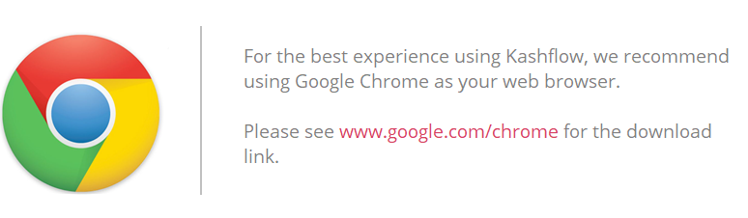

Javascript Turned On
Kashflow Payroll uses Javascript to make your experience of our system smoother and faster. It is not possible to use Kashflow Payroll without having Javascript switched on, you will see a warning message.
If you are unsure about how to switch on Javascript, or would like to check, visit enable-javascript.com.
The following suggestions will help you get the most out of Kashflow Payroll:
- Use the latest browser (we like Chrome for the best browsing experience).
- Ensure that you have the Adobe PDF Reader installed.
- If you use Firebug, disable it during your Kashflow Payroll session for better page performance.
- To view reports in Excel format you will need either Microsoft Office Excel installed or a compatible free viewer from Open Office
- Check your screen resolution is at least 1024 x 768
- If Kashflow Payroll isn’t loading, or times out, it might be that you are having trouble connecting to the internet. Here are a few things to try:
  - In the same browser, check that you can get to other websites, e.g. www.google.com
  - If you can connect to the internet but are still having trouble try shutting down/closing the browser completely and re-opening it, or even another browser and trying again

Creating your Kashflow Payroll Account
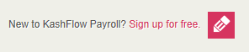
To create a Kashflow Payroll account go to go.kashflowpayroll.com and click on the sign up link in the top right hand corner of the screen.

At this stage, you will be asked to enter your name, email address and telephone number. Please note that this email address will be used as your login email address. You can change this at a later date.
You must read the Terms of Use at this point before being allowed to continue. Once this is done, you will be sent an activation email that will ask you to create a password for Kashflow Payroll. Your password must contain letters, numbers and one character that is not a letter or a number, for example an item of punctuation such as a question mark.
Please note, if you do not receive your activation email within 60 seconds of sign up, check that you have entered a valid email address or use the link at the bottom of the sign up screen that will re-send your activation email.
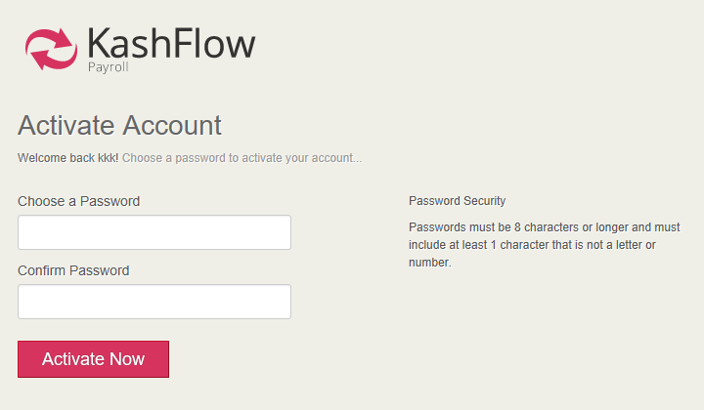
Upon successful creating your password, you will be taken to the Kashflow Payroll setup wizard to add your practice details; alternatively, you can explore the system using the free demonstration company.

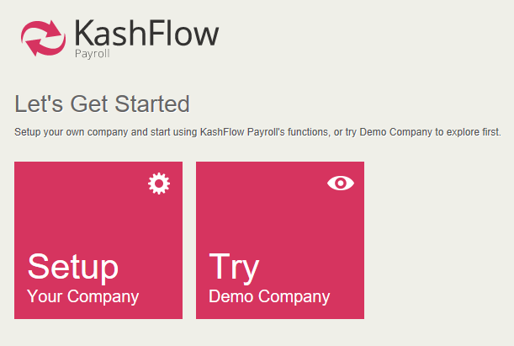
Forgotten password
If you are looking to change your password for Kashflow Payroll account, you can do so by clicking the Forgotten Password link on the log in screen.
You will then need to enter the email address you use to sign into Kashflow Payroll.
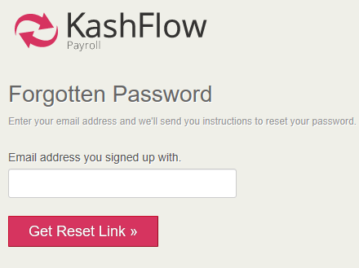
Your new password will be sent to your email immediately.
Haven’t received your new password?
If for whatever reason you don’t receive the link, then ensure you check your spam/junk folders.
Still not there? Contact Kashflow Support by emailing support@kashflowpayroll.com.

Kashflow Payroll Layout
Kashflow Payroll is simply organised with a main menu or navigation area down the left-hand side, and your working content – the practice and employee you’re currently working on – across the top.

Company and Employee Selection
The dropdown menu at the top of the screen contains the practice name(s) that you have set up in the system. Clicking the drop down allows you to select which practice you would like to work on, and then from the second dropdown you can select the employee you wish to view.
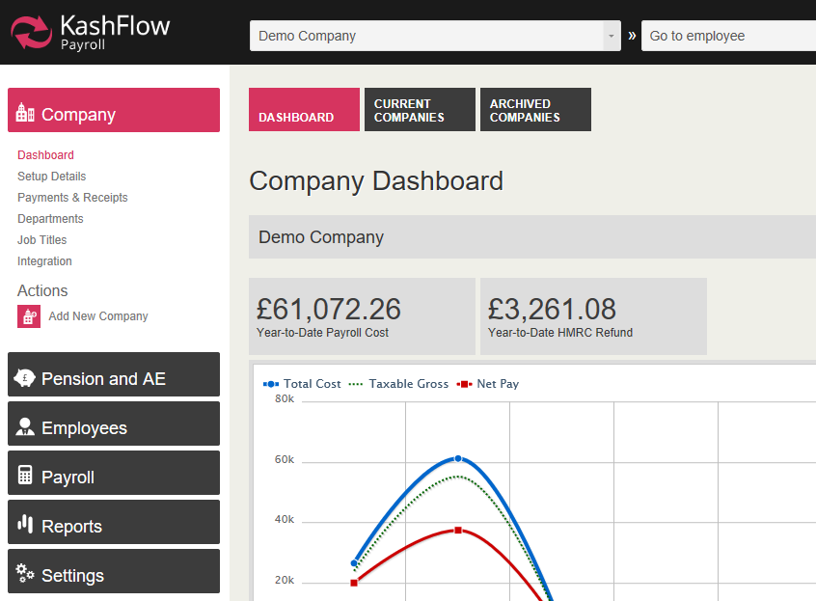

The name and gear icon to the right of the screen give you quick access to your own user profile and system log out.

Using the employee and company context menus
These menus play a special role in how you use Kashflow Payroll and help you to quickly move around the system to complete your payroll.
Company Context
Click the box to see a drop-down list of all practices you have set up in Kashflow Payroll, then click onto the practice that you want to open.

Employee Context
You can select employees by clicking on this box and selecting a name. If the current page contains employee related data (e.g. Employee Personal Details) you will remain on this page but the information displayed will be for the employee you have selected. However, if you are on a non-employee related page (e.g. Company Dashboard) then selecting the employee will take you to that employee’s dashboard.
Also note that the employee context dropdown list is sorted alphabetically by employee name and only ever shows the first 18 current employees. If you have more employees than that in Kashflow Payroll, just start typing any part of the employee’s name and the list will change to show employees matching the text you type.

Main Menu
The main menu for Kashflow Payroll is down the left-hand side of the screen and contains:

Company
Contains all practice related data and actions for the practice you are currently working with.

Pension and AE
This screen allows you to configure and manage your alternative qualifying pension scheme for auto enrolment. From here you can also view pension communications to be sent to employees and add additional (non-NHS) pension schemes.

Employees
Employee specific dashboard, setup information, NHS Pension and other pension details, absences, statutory leave and arrestment orders. Note that whenever you are in the employee area, you will see data for the currently selected employee.

Payroll
This is the area where you will run payroll, enter adjustments, generate payslips and make your RTI submissions.

Reports
Generate your payroll, employee, pension and statutory reports here.

Settings
This area is where you can see your account and billing settings, and billing history.

Tabs
Most screens within the program have tabs at the top, as illustrated below. These tabs provide access to pages within the chosen section.

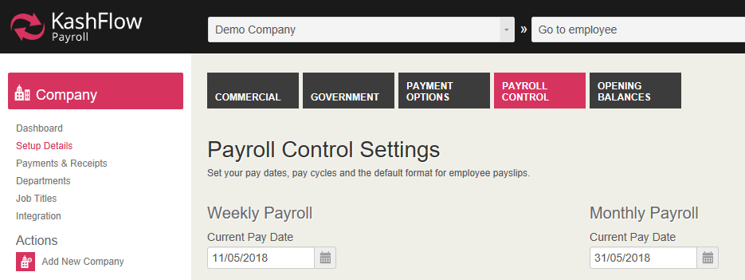

Dashboard
There are two main dashboards in Kashflow payroll, the company dashboard and the employee dashboard.

Company Dashboard
The company dashboard is your homepage for the practice, and each practice that you have set up will have its own dashboard. From the dashboard you can go directly to the current pay date and manage payslips, see a graphical overview of your last 12 months of payroll, and find system messages alerting you to important evens within the practice payroll.

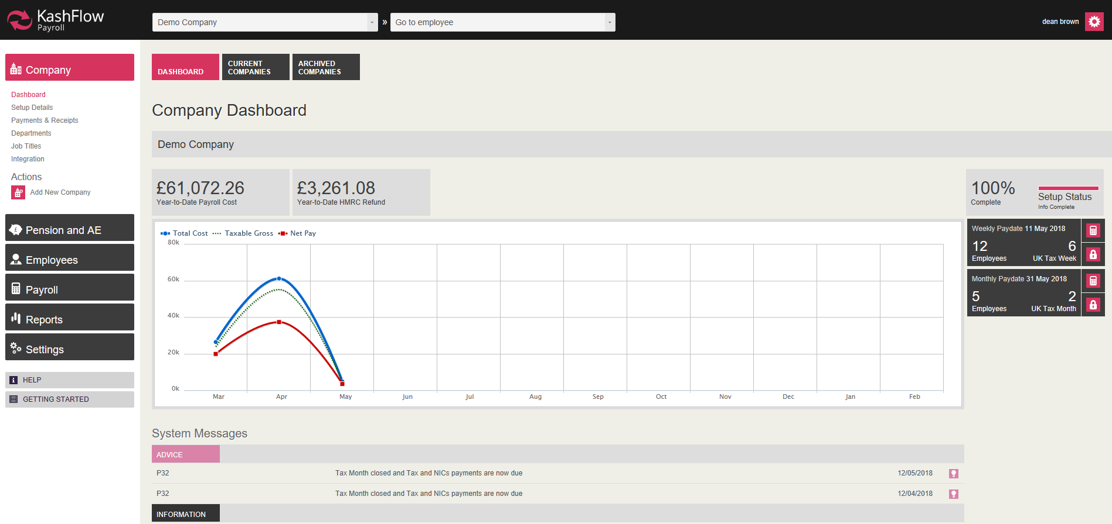

Employee Dashboard
The employee dashboard is specific to each employee and there is a dashboard page for each employee in the system. The employee dashboard gives you the Year-To-Date net pay figure, a graphical summary of recent pay to an employee, quick view-and-print of their last 6 payslips and a brief summary of employee statistics.
The following actions are also available for you from the employee dashboard:
- Go to current payslip
- Set employee’s directorship
- Make an employee a leaver
Note that these actions change if the employee you are looking at is already a leaver, in which case you will be able to:
- Go to leaver’s last payslip
- Re-join this leaver as an employee
- Download/print a P45
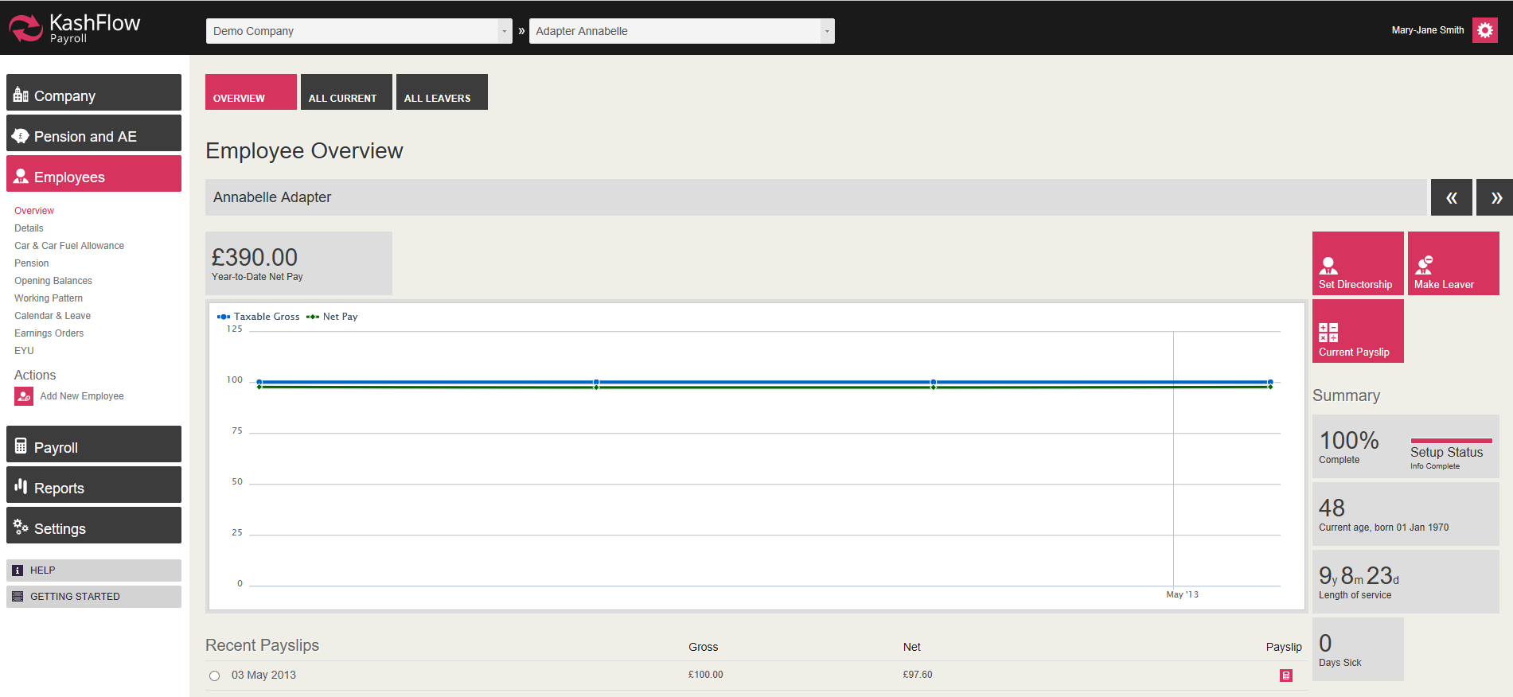

Adding a new company
Required information
To set up your practice details with sufficient information to process your payroll, you’ll need to ensure you have a few key pieces of information.
You can enter just the basic information of adding a new company to get going; however, we recommend that you fully complete company setup to avoid having to return to fix things later.
After setup you can change or complete any missing information using Company >> Setup Details from the left-hand main navigation.
If you already have payroll software that you are moving from, you should be able to collect this information from your existing software’s setup screens. If you are unsure about where to find any of the data required for company setup, check with your accountant, HMRC or support@kashflowpayroll.com.
Information you’ll need:
- The correct legal name of the practice.
- Your current monthly and/or weekly pay date. You will need to enter the next pay date into Kashflow Payroll. You can pay employees using both frequencies at the same time in Kashflow payroll.
- Employer PAYE Reference. Your office and reference number you should be able to find on the yellow PAYE payslip booklet or any other correspondence from HMRC.
- Accounts Office Reference. You will find this 13-character reference number on the PAYE Payslip booklet other correspondence from HMRC, and will be in the format 123PA12345678.
- Practice Reference Number. This is the unique reference number allocated to you by the health authority. Make sure this is entered correctly, and in the right format as (for Scottish practices particularly) entering the incorrect number could cause problems when making submissions at year end.
- HMRC Online Filing Credentials: These are the details required to make online submissions to HMRC, and include the User/Internet ID, password and sender details. If you are moving from another payroll provider, you should be able to obtain these from the company set up/PAYE details screens.
- Your banking information. If you plan to pay your employees by electronic transfer (BACS) you will need your BACS format, bank account name, account number and sort code to hand.
- Opening balances. These are your statutory payment recovery year-to date amounts (e.g. SMP Recovery), Employment Allowance and Apprenticeship Levy Allowance year-to-date amounts.

Commercial Information
Within this tab you will enter the name, address and telephone details for the practice.
Note: The Business Type field is an optional field but gives us an idea of the type of company. For a practice, you would select ‘Healthcare’

Government Settings
Each practice Kashflow Payroll represents a PAYE Scheme and HMRC will have provided unique information to help identify you in RTI submissions. You should complete the fields that apply to the practice.
Employer PAYE Reference: You will find this reference on the yellow PAYE Payslip booklet or any other correspondence to the practice from HMRC
Accounts Office Reference: This 13-character reference number should also be shown on the yellow payment booklet or correspondence from HMRC, in the format 123PA12345678. References that aren’t 13 characters long require zeroes (0) entering after the two letters to make it up to 13 characters, e.g. instead of 123PA45678 you would enter 123PA00045678
Corporation Tax Reference: This reference, also called the Company Unique Taxpayer reference (UTR), is 10 digits long and applies to limited companies. You will find this reference on the ‘Notice to deliver a company Tax Return’ (HMRC form CT603)
Please Note: This does not usually apply to GP Practices
Self-Assessment Unique Tax Reference: This reference is 10 digits long and usually applies to sole proprietors or partnerships. You will find this reference on a Self-Assessment return that you have made to HMRC.
Please Note: This does not usually apply to GP Practices
Will you be claiming the Employment Allowance? Select Yes if the practice is eligible to offset employment allowance (currently this is £3000 per year) against Class 1 Secondary NICs paid over to HMRC each month. If you are starting to use Kashflow Payroll mid-year you can enter the Employment Allowance already claimed in the Opening Balances tab
Are you eligible for Small Employers Relief? Select Yes if the practice qualifies for relief on statutory payments (that is, Statutory Maternity, Paternity, Adoption and Shared Parental Pay) made, so that 103% of the statutory payment is reimbursed through the amount you pay to HMRC each month. To qualify for this relief, the total amount of NIC paid by the practice in the previous tax year must be less than the Small Employer’s Relief threshold (this is currently £45,000). If the practice doesn’t qualify for relief then statutory payments are still reimbursed through the amount you pay to HMRC each month, but only at a rate of 92% of the payment. If you are starting to use Kashflow Payroll mid-year you can enter reimbursement amounts already received on statutory payments in the Opening Balances tab.
Has this company previously participated in RTI? If this is not a new practice you are setting up and you have previously made RTI submissions to HMRC, select Yes.
Would you like Kashflow Payroll to calculate Apprenticeship Levy payments? Select Yes to this message if your pay bill is over £3 million each year. This means you will be paying apprenticeship levy at 0.5% of your total pay bill after the apprenticeship levy allowance amount is used. If you are starting to use Kashflow Payroll mid-year you can enter the apprenticeship levy already used in the Opening Balances tab.
Enable RTI Filing? Select Yes in order for Kashflow Payroll to automatically make RTI submissions to HMRC.
Enable CIS Deductions? You should only select Yes if you are reducing your payments to HMRC by the value of any tax deduction automatically made from invoices by a contractor.
Please Note: This does not usually apply to GP Practices
Online Filing by: Select Use own credentials. When selected new fields will open up:
- Internet/Login ID and Password: These are the logon details issued by HMRC for their online portal
- Sender Name: Enter the name of the person responsible for making RTI submissions
- Sender Address and Postcode: Enter the address details of the practice Contact Name, Telephone and Email: Enter the details of the person responsible for making RTI submissions

Payment Options
This screen allows you to select the default method of paying your employees. You can override this setting per employee. You can pay your employees by:
- Cash
- Cheque
- BACS (Electronic Transfer)
- Other
If you pay by BACS then you can enter the practice bank details in this screen, and then as you process payroll each period you will be able to create an export file compatible with your banking system. You can import the BACS file to your banking software to pay your employees directly.

Payroll Control
This screen allows you to configure your pay dates in Kashflow Payroll. We understand that practice employees are generally paid on a monthly basis but Kashflow Payroll gives you the freedom to also configure Weekly pay dates in the event that you needed to pay any staff on a weekly basis, and both pay frequencies can be processed side by side.
Current Pay Date: Enter in this field your next pay date, so for example if you last paid your monthly employees on 30th April, enter the May pay date.
Period Start Date: Enter in this field the first day of the period that your current pay period starts. For example, you might pay on the 28th of each month, but the payment may cover the whole month from the 1st to the last day of the month, so you would enter 01/mm/yyyy in this field. Alternatively, your pay date might be the last day of each month, but the period covered might be in line with the tax calendar so you would enter 06/mm/yyyy in this field.
Default Pay Date: This menu allows you to select the default pay date so that the system knows what every subsequent pay date will be, so for example you could select ‘Last day of the month’ and the system will identify that your pay date from this point onwards will always be the last day of the month.
Bank Holiday Settings: This section allows you to select the region of the UK that your bank holidays fall under. You can then instruct the system what to do when a pay date falls on a bank holiday, i.e. should the pay date remain as it is, change to the previous working day or the next working day.
Payslip Format and Delivery: This section allows you to select the format of payslip that you plan to use for employees and also how the payslip should be delivered. If you intend to print and issue payslips by hand to employees, you would select ‘Print from PDF’. Alternatively, you can opt to send payslips electronically, via Kashflow Payroll’s ‘Electronic Self Service.’ This means that each time pay is finalised, employees receive an email advising that their payslip is ready to view online. They click a link within the email, and log in using their email address and are then able to view current and historical payslips.
To configure these details, select Employee Self Service as the Payslip Delivery Method. You will then set Employee Self Service for each employee (and their email address) and the system will automatically create electronic payslips when pay periods are finalised.
Ceased Trading Date: You should only enter a date into this field if the practice has ceased trading. Entering a date will effectively mark all your employees as leavers and prevent you from processing pay for them again, so this field should be used with caution.

GP Settings
This screen is where you can configure your practice settings and controls. Firstly, select the Pension Agency region; this will then automatically set the employer’s NHS Pension contribution rate.

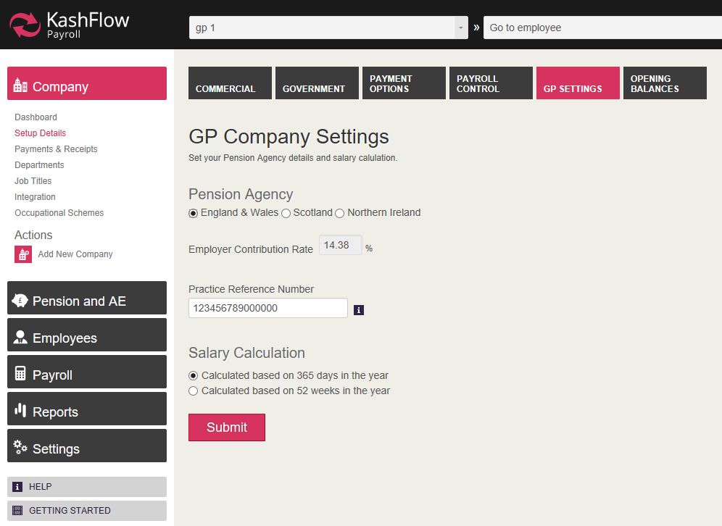
Enter the Practice Reference Number, making sure you enter this correctly in the format expected by the NHS Pension Scheme region.
For example, for Scotland, the practice reference number must consist of 15 characters - starting with 2 letters followed by numbers. If the reference number you hold is not 15 characters you must enter subsequent zeroes after the number you have. So for example, if your Scottish practice reference number is GP123456, you must enter GP1234560000000. It is important that you enter these details correctly, as this is used by NHS Pension Scheme to identify the practice and employees within the practice.
Salary Calculation: The section controls how your hourly paid employee’s monthly salary is calculated. The salary of an hourly paid employee is calculated by firstly multiplying the hourly rate by the hours worked per week. This then needs to be converted into a monthly salary.
By selecting ‘Calculated based on 365 days in the year)’ the monthly salary is calculated as follows:
Monthly salary = (rate per hour X hours per week) divided by 7, multiplied by 365 and then divided by 12
By selecting ‘Calculated based on 52 weeks in the year’ a simpler calculation is used:
(Rate per hour X hours per week) multiplied by 52 and then divided by 12)
The method you use is decided by your health authority, although in our experience the most common method is based on 365 days in the year.

Opening Balances
Opening Balances informs Kashflow Payroll what the year-to-date figures were before you started using the software, so you would only ever need to enter these values once, and even then only if you had previously processed payrolls for the year. Based on the pay dates you have entered, Kashflow Payroll will automatically identify which year you will need to enter Opening Balances for.
Before you process pay for the first time in Kashflow payroll it is strongly recommended to enter the Opening Balance values. If you previously used another payroll provider these values should be easily available, either from a similar screen to the Opening Balances screen in Kashflow Payroll or by printing a report that shows the amounts that are due to be paid to HMRC – as these generally contain the year-to-date balances of recovery amounts and allowances.
Zero Values: Opening Balances might be zero if:
- Your company has not made any statutory payments during the year, and therefore there are no recovery amounts to be entered
- Payroll has not been processed for the practice for the year so far (e.g. you are a new practice and have not paid any employees before)
- You started using Kashflow Payroll for the first week or month in April

Payments & Receipts
This screen allows you to quickly view and manage the payments you make to and receive from HMRC.
Payments
This section shows the total amount you owe to HMRC for each tax month processed in Kashflow Payroll. In here you can click on each month displayed and a comprehensive breakdown of the elements that have counted towards the money due to HMRC for the tax month. From this screen you can also print a report to show the values due to HMRC (the P32) and mark the period as having been paid to HMRC.
Receipts
This section allows you to manually enter any payments that you have received from HMRC. A payment from HMRC could be for statutory pay funding, a Tax or NIC Refund or a Tax Free Incentive.

Departments
Use this screen to create Departments for the practice. These can then be assigned to each employee. Payroll figures can be analysed by Department in the Reports menu, and during payroll run you can even assign pay items to different departments, for example, if an employee does some overtime to help another department.

Job Titles
Use this screen to set up all of the Job Titles within the practice. These can then be assigned to employees. This screen will then display the number of employees working at each job title.

Integration
If you use Kashflow for your accounts, this screen allows you to configure and automatically post your payroll costs direct to your nominal ledgers in Kashflow, saving time and avoiding errors.

Occupational Schemes
This screen allows you to add and manage local contractual schemes for maternity and adoption leave, which can be applied to employees when they are entitled to more than the standard statutory maternity and adoption payments.
In here you can create different schemes, which can then be selected when adding maternity or adoption leave to individual employees.
To create a scheme, select a leave type from the Occupation Scheme Types menu, and click Add Scheme. A screen will be displayed, requiring you to give the scheme a name, e.g. ‘Agenda for Change.’ You then need to enter a number of weeks for each pay ‘level’, and the total weeks must always equal 52. Here’s what each pay ‘level’ means:
Full Salary: This is often paid for 8 weeks, and means that the employee will receive normal full salary for 8 weeks from the start of the absence. The system will still calculate the SMP/SAP element and include this within the normal salary value so the practice can still claim the recovery of SMP/SAP from PAYE.
Half Salary plus Low Rate: This is often offered for 14 or 18 weeks, depending on the scheme type and means that the employee will receive half of their normal salary for the number of weeks specified with SMP paid on top. In the event that half salary plus SMP equates to more than what the normal full salary would be, the payment will be capped to the full salary value.
Low Rate SMP Only: The number of weeks entered must be 39 weeks (the maximum number of weeks SMP an employee can receive) less the number of weeks entered for Full Salary and Half Salary. For example, if number of weeks @ full salary = 8, and the number of weeks @ Half Salary = 18 then number of weeks @ Low Rate SMP should = 13.
Unpaid Maternity Leave: As low rate SMP has to be paid until the 39th week, and the Total Weeks should always equal 52, it would be normal to enter 13 weeks of unpaid maternity leave. Even if the employee intends to return before the 52nd week you should still assume 52 weeks is the initial plan.

Import Data
If you are moving from another payroll provider, you may be able to import your employee data directly into Kashflow Payroll, saving you lots of time and effort. See our Import/Export Guide for further assistance.

Automatic Enrolment
Automatic enrolment has been in place in the NHS Pension Scheme for a long time, as it is part of the existing joining process. Employers in the NHS are required under the NHS Pension Scheme regulations to automatically enrol all eligible employees into the NHS Pension Scheme from the first day of their employment. That process should still be followed, so once a new employee record is created they must be entered into the NHS Pension Scheme.

However, there are some exclusions to joining the NHS Pension Scheme - such as an employee who has retired from NHS Pension Scheme due to their age, but are still within the age restrictions for auto enrolment - and for this reason the practice must offer an alternative qualifying pension scheme. The system will then assess any employee not already a member of the NHS Pension Scheme and - if eligible - will enrol them into the alternative scheme.
To set up your alternative qualifying pension scheme select the Pension & AE menu from the left of the main screen, and select AE Setup. You will need the following information in order to set up your alternative scheme. If you are moving to Kashflow Payroll from another payroll provider, you should be able to easily access this data from the AE Configuration screens in your previous software.:
- Duty Start/Staging Date
- Postponement details: Duty Start/Staging and New Starter periods
- Pension Scheme Details, e.g. contact name, address etc.
- Pension deduction rules for your chosen pension provider, e.g. ‘Relief at Source’, ‘Salary Sacrifice’, ‘Under net pay arrangement’
- How the pension will be calculated, e.g. is it deducted as a percentage or value?
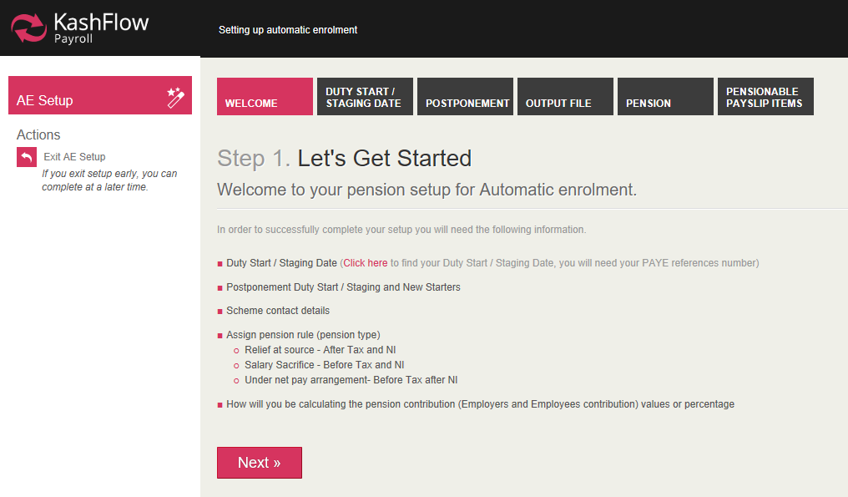

Staging Date
Enter your staging date, excluding any postponement period. If you do not know what your staging date is you can locate it by entering your PAYE Reference Number at www.thepensionregulator.gov.uk.
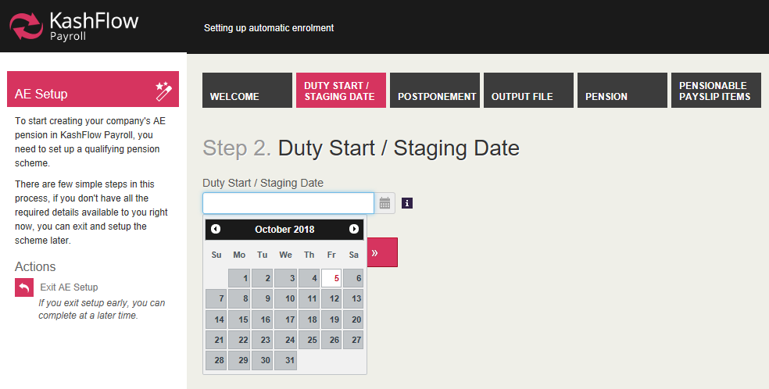

Postponement
There are two types of postponement periods that can be used:
Postponement Period: Staging Date and New Starters. This means that a postponement period applies from the staging date or from the date a new employee started.
Postponement Period: Eligible Jobholders: This means that the postponement period applies from the date an employee becomes an eligible jobholder; this is to cater for the scenario where an employee who normally does not earn enough to be automatically enrolled into a scheme but due to a one-off spike in pay they become eligible.
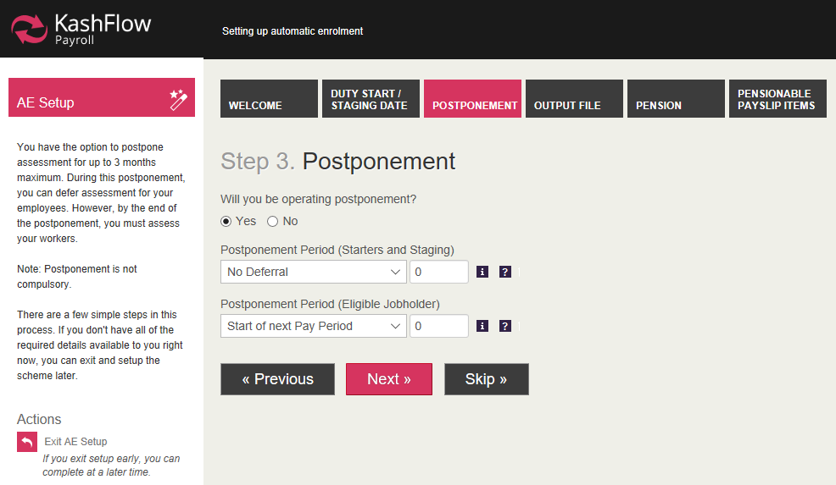

Output File Configuration
This tab is where you can enter details about your chosen pension provider. Depending on which output file format is selected, you will then need to enter additional information that will be provided by the pension provider.
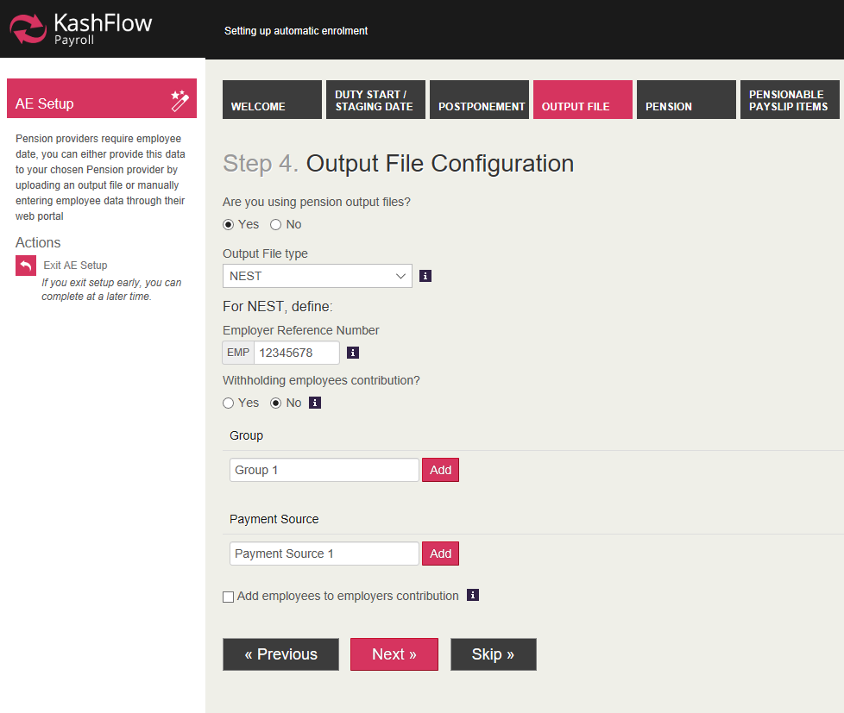

Pension Configuration
This screen is where you can enter further information about your chosen pension provider: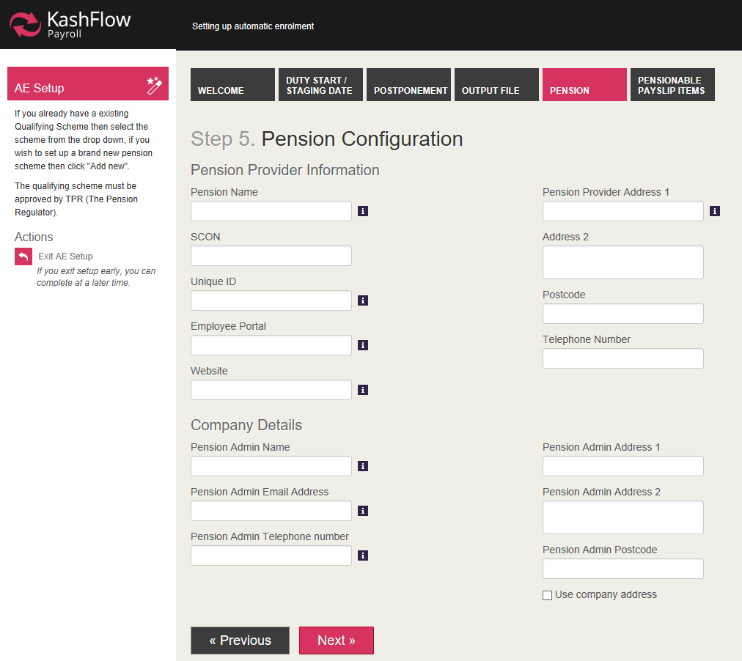
Pension Name: Enter the name that you want to give the pension scheme; for example, if you plan to have different pension schemes for different employees you could call the pension ‘Pension – staff’, ‘Pension – managers’ and so on.
SCON: This number should be provided by the pension provider.
Unique ID: This is another way to differentiate between pension schemes; you can give each scheme you create it’s on unique identifier.
Employee Portal: This should be the pension providers web portal link which the employees can use to login to their accounts.
Website: Enter your pension provider’s website.
Pension Provider Address, Postcode and Telephone Number: Enter the contact details of the pension provider.
Pension Admin Name, Email, Telephone number, Address, Postcode: These should be the contact details of the person within the practice who is responsible for looking after the pension administration.
Assign Pension Rule: In this section you should determine the payroll conditions under which the pension contribution will be deducted:
- Relief at Source: This means that tax and NI will be calculated before the pension has been deducted
- Salary Sacrifice: This means that tax and NI will be calculated after the pension has been deducted
- Net Pay Arrangement: This means that tax is calculated after, and NI before the pension has been deducted
Contributions
This section is where you can enter the employee and employer pension contribution values that will be applied to the employee if they are set as eligible jobholders after automatic enrolment assessment has been made. Values can be entered as a percentage (most commonly used) or as a monetary value.

Pension Scheme options
In this section, select the options that apply to your chosen pension scheme:
- Tick Qualifying Scheme to confirm that your chosen provider has been approved by TPR. Under auto enrolment schemes, you must have at least one qualifying pension scheme.
- Tick Automatic Enrolment Type to confirm that the pension deductions made meet the minimums defined by TPR and that contributions are calculated against qualifying earnings and are subject to earnings thresholds.
- Tick Default Scheme if the pension provider’s details screen you have open is the one you are using as the default automatic enrolment scheme; you can have multiple pension scheme details set up, but only one can be the default scheme (with the exception of NHS Pension Scheme)
- Tick Subtract Basic Rate Tax for the employee pension contribution to be reduced by the basic rate of tax. Note: This option only applies where the pension rule is ‘Relief at Source’.
- Do you want the system to generate output files for your provider? Tick this option and select the pension provider from the menu if you want Kashflow Payroll to generate output files containing pension information to your chosen provider.

Pensionable Payslip Items

Use this screen to identify which payslip items are included in the calculation of pensionable pay and in the calculation of qualifying earnings. For example, a Christmas Bonus may form part of the employee’s pensionable pay calculation but does not count towards qualifying earnings threshold when assessing the employee for auto enrolment.

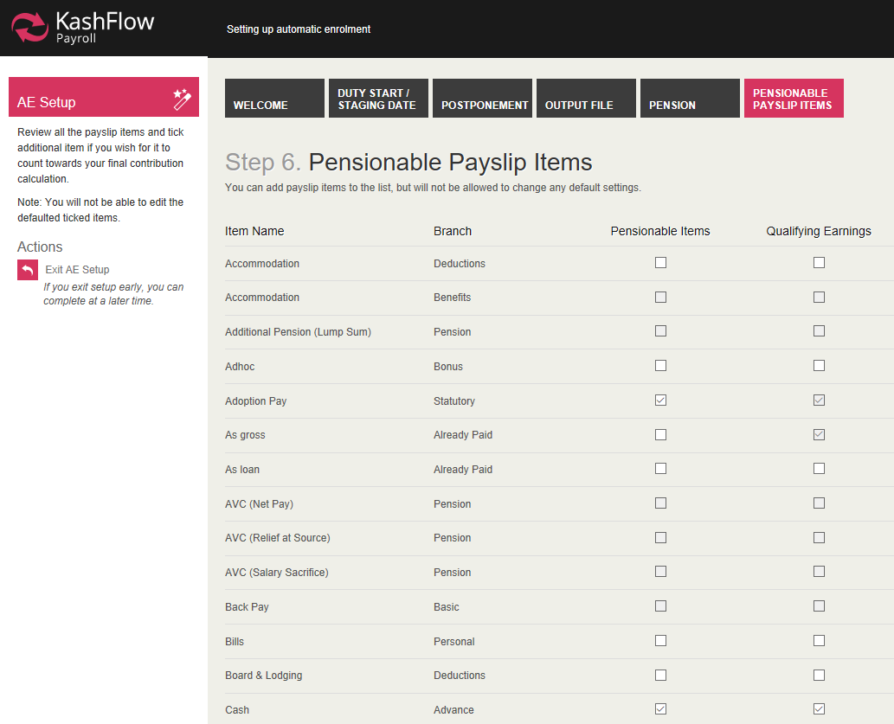

Assessment of Employees
Automatic assessment of employees is carried out within a normal payroll run, once AE setup is complete, based on the criteria listed below:
- Employee is not already enrolled into NHS Pension Scheme
- Employee is aged between 22 and state pension age
- Employee earns more than the current earnings trigger for Auto Enrolment
- Employee works in the UK
Assessment must take please during each payroll run to ensure that any changes to employee circumstances are captured and reflected. Kashflow Payroll automates this process for you.
It is important to ensure that all employees (including new employees who join the practice from now on) who are eligible to join the NHS Pension scheme are configured before running the payroll.

Communications
In order to remain auto enrolment compliant, you must generate pre-approved pension communications to employees. These can be viewed via the Pension & AE > Communications screen.
When a pay period is finalised, necessary pension communications are automatically generated based on the following information:
- Staging Date
- Postponement settings
- Pension Status of your employees
There are standard letters that are generated based the outcome of each AE assessment:
- L1 – Eligible Jobholders
- L2 & L3 – Non-eligible Jobholders and Entitled Workers
- L6 – Postponement all Workers
In addition to the above, in the case of postponement, additional letters may be generated with a suffix ‘P’ to denote that postponement is in operation with adjusted dates.
When payroll is finalised, any communications that were generated will be listed, by employee, in the Communications screen. From here you can download messages and view, print or publish messages.

Output Files
Once you have finalised each payroll run with auto enrolment, you need to communicate with your chosen pension provider to inform them of contributions made, opt-outs, leavers etc.
As well as configuring your pension provider details in the Output Files Configuration screen, you must also inform the system that you require the output file to be generated automatically – this is configured in the Configure Pension Scheme screen, in the Scheme Options section: tick the box asking ‘Do you want the system to generate output files for your provider?’. When this is ticked the system will ask you to confirm the output file type (e.g. ‘NEST’).
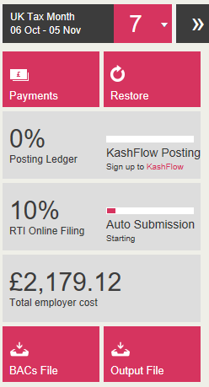
Once these details are set, you can create your pension output file each time pay is finalised from the Payslips & Periods screen. Select the Output File button for the file to be created.

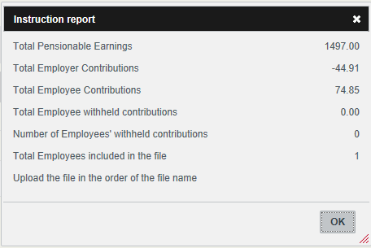
A screen will be displayed that shows a summary of the file to be uploaded and it’s contents.

Once you have checked this the file is ready to be submitted to your pension provider. Note: You must submit this file yourself; it is not automatically submitted in Kashflow Payroll.

Employees

The Employees section in Kashflow Payroll is where you can add new employee records, view or change an existing employee record or make changes to an existing employees year to date values for a previous year via an EYU submission.

To access the Employees section, click onto the Employees menu in the left hand of the screen, which will open a list of sub-menus.

If there are existing employees already set up in Kashflow Payroll you can select their name from the employee dropdown at the top of the screen and then select a menu item from the Employee menu to view or change the selected employee’s details.

To create a new employee record, you can click onto the Add New Employee option, which will open a blank employee template. The system will then take you through a series of screens to easily create the new record.

Adding new employees

Required Information

Now that you have entered information about your practice and your pension information is complete you can start to add employees onto the system.

Before you can use Kashflow Payroll to process pay and produce payslips, you must have at least one employee set up for whom you have completed all the required setup fields.

If you have previously used another payroll provider, such as IRIS GP Payroll, you can import your employee data in just a few easy steps. See our Import/Export Guide for further information.

If you are entering employees into the system manually, you will need, as minimum, the following details:

- Join Date: The date the employee started their current period of employment at the practice
- Employee Address and Postcode
- Date of Birth and Marital Status
- Tax Code: This would normally be obtained from a P45 (if it is a new starter) or from your previous payroll system
- Tax Calculation Method: This would normally be obtained from a P45 (if it is a new starter) or from your previous payroll system
- National Insurance Number (NINO) and Category: If you do not have this information you can request it from HMRC
- Employee NHS Pension Scheme Details
- Employee banking information: If you plan to pay the employee by BACS you will need their bank account name, account number and sort code
- Opening Balances

To create a new employee record, click the Employee menu and then select Add New Employee

Note: Do not use the Add New Employee option to create a record for a practice partner: use the Add New partner (Type 7) action instead.

The Basics

The first screen displayed when setting up your employee is The Basics tab. In here you need to enter the following details:

First Name(s): Enter the employee’s forename, and middle name(s) if applicable

Last Name: Enter the employee’s surname

Is this employee new to your company? If the employee is a new starter, click Yes. If they are not a new employee, for example if you are entering employee details because you have moved from another payroll provider, select No.

If the answer to ‘Is this employee new to your company?’ is Yes, you will be required to enter Starter Declaration information. When creating a new employee record, HMRC need to know what kind of starter they are. If the employee has provided you with a Starter Checklist form (originally, this was called the P46 form), or a P45 from their previous employee then you can use the information provided to help to complete this section.

- If P45 has been provided:
  - If the leave date on the P45 is within the current tax year, select option B
  - If the leave date on the P45 is prior to the current tax year, the employee should complete the Start Checklist instead
- If Starter Checklist has been provided:
  - If this is the employee’s first job since 6th April of the current tax year and they have not been receiving Jobseeker’s Allowance, Employment and Support Allowance, taxable Incapacity Benefit or State or Occupational Pension, select option A
  - If this is the employee’s only job but since 6th April of the current tax year they have worked elsewhere, or received Jobseeker’s Allowance, Employment and Support Allowance or taxable Incapacity Benefit, select option B
  - If this is not the employee’s only job or they receive a State or Occupational Pension, select option C
- If the employee has not provided a P45 or Starter Checklist, select option ‘Unknown’

Is the employee starting as a director? Select Yes If the employee is, or has been, within the current tax year. You will then need to enter the date that the directorship started (and if directorship ended within the current tax year, enter the End date) and the NIC Calculation Method to use. Director’s national insurance is treated slightly differently to normal employees in that the NIC thresholds are applied annually rather than per pay period, but you can opt for their NIC thresholds to be applied in the same way as normal employees:

- As director: Using this option, the NICs are calculated cumulatively, in that annual thresholds apply, and NIC is only deducted once pay reaches the annual thresholds
- Like Employee: Using this option, the NICs are calculated non-cumulatively, which is how NICs are normally calculated for employees. Using this option, however, means that in the final payment of the year (or the final payment as a director) Kashflow Payroll will automatically re-calculate NICs on a cumulative basis (as required by HMRC for directors)

Both methods are perfectly fine to use, although many directors prefer to be paid using the ‘Like Employee’ method, as this creates more consistent payslips each period than using the ‘As director’ method, which can cause payslip values to fluctuate (e.g. a director may not pay any NICs for the first few periods of the year, followed by periods where they pay NICs on all earnings once annual thresholds have been reached)

Note: If you are entering details for a director who you previously paid using another payroll provider you should ensure that you select the same option as was set on the previous system.
Please note: A director is not the same as a partner in the practice, a partner is not included within PAYE but can be entered into KashFlow payroll to create drawing slips.

Personal Details

In order to help HMRC identify an employee, especially a new starter, some personal information is required:

Title: Select the employee’s Title from the menu

First Name(s): This field should be automatically completed, as you will have entered this information in the Basics tab

Last Name: This field should be automatically completed, as you will have entered this information in the Basics tab

Known As: Whilst the First Name and Last Name boxes should hold the full and correct employee name (as seen on the birth certificate or passport), the Known As box can be used for the informal or nickname as preferred by the employee, e.g. An employee’s first name might be Anthony, but they prefer to be known as Tony, so you would enter this in the Known As field.

Gender: Select the employee’s gender.

Date of Birth: Enter the employee’s date of birth

Marital Status: Select the appropriate option from the menu

Contact Details

This tab gives Kashflow Payroll some address and contact details about your employee:

Employee Address: HMRC require at least two lines of an employee’s address, so ensure you complete the Employee Address and at least one line of the Additional Address Lines

Postcode: If the Country is United Kingdom, HMRC require a valid UK postcode

Country: United Kingdom is set as default, although you can select a different option from the menu

Telephone Numbers: These are optional fields, although you should enter any contact telephone numbers for the employee that you have.

Employment Details

This tab is where details about the employee’s contract and the nature of their employment are entered:

Employee Number: This number is automatically generated by Kashflow Payroll and cannot be edited

Select a Job Title/Or, enter a new Job Title: You can either select the Job Title from the pre-populated list, or enter a new Job Title name. When you enter your own Job Title name, this is saved into the list, so that if you are setting up another employee record with the same job title it is already saved in the list without you having to re-enter it.

Department: Select the employee’s department from the list. Departments are created at Company level, so any you have already created will be available to select from the list.

Join Date: This field should be automatically completed, as you will have entered this information in the Basics tab

Leave Date: This field will only be displayed if the employee has had a leave date entered in the current tax year.

Director Information: If the employee is a director then their director information will be displayed here in read-only format.

Government Details

Each employee in Kashflow Payroll will require some details entered to help identify them to HMRC and in RTI submissions. In turn, each employee will require some details from HMRC to enable Tax and National Insurance Contributions (NICs) to be calculated correctly:

Tax Region: An employee’s tax region is defined by where they live: If they live in Scotland, the tax region should be set to Scotland. If they live in Wales, the tax region should be set to Wales. If they live anywhere else (i.e. England or Northern Ireland), set the tax region to England and Northern Ireland (rUK)

Tax Code and Tax Calculation Method: If Tax Region is set to Scotland or Wales, the tax code field will automatically insert a prefix of S (Scotland) or C (Wales), and you just need to enter the remainder of the tax code. If you are moving from another payroll provider, you should enter the tax code used in your previous software for the employee. If you are setting up a new employee record you can obtain the tax code from the employees P45, or from a PAYE coding notice sent to you from HMRC or you can use the starter checklist to ascertain which tax code to use:

- Starter Checklist Option A is set: Use the current tax year’s emergency tax code, with Tax Calculation Method set to ‘Normal’
- Starter Checklist Option B is set: Use the current tax year’s emergency tax code, with Tax Calculation Method set to ‘Week 1/Month 1’
- Starter Checklist Option C is set: Use tax code BR with Tax Calculation Method set to ‘Normal’
- Starter Checklist Option Unknown is set: Use tax code 0T with Tax Calculation Method set to ‘Week 1/Month 1’

Should Student Loan repayments be deducted? If you are moving from another payroll provider you should be able to easily ascertain if the employee is making student loan repayments, and the plan type to assign. If you are setting up a new employee record, you can find out if student loan repayments should be made from:

- The employee’s P45, if they have provided one
- The Starter Checklist, if the employee has completed one
- Student Loan Notice (SL1) from HMRC

Currently, there are two different Student Loan plan types. Plan 1 is used for English and Welsh students whose course started before 1st September 2012, and for all Scottish and Northern Irish Students. Plan 2 is used for English and Welsh students whose course started on or after 1st September 2012.

A Student Loan Notice (SL1) will inform you which plan type to use. The P45 or Starter Checklist does not advise which plan type to use, so (unless the employee can tell you which plan type they’re on) you should use plan type 1.

National Insurance Number (NINO): This is one of the key ways that HMRC identifies an employee. If you are moving from another payroll provider, you should be able to easily access the NINO from the employee record in your previous payroll software. If you are setting up a new employee record, you should be able to obtain the National Insurance Number from a P45, Starter Checklist or from a notification from HMRC.
Note: You should never enter a fake or temporary NINO: if you do not know the employee’s NINO, leave the field blank.
National Insurance Category: The National Insurance Category letter is used during payroll run to determine how much employee and employer national insurance should be paid. If you are moving from another payroll provider, you should be able to identify the current NI Category (or it may be referred to as NI Code) to use from the employee record. If you are setting up a new employee record use the guide below or visit HMRC website to identify which category to use:
Category Letter | Employee Group
A | All employees apart from those in groups B, C, J, H, M and Z in this table
B | Married women and widows entitled to pay reduced National Insurance
C | Employees over State Pension age
J | Employees who can defer National Insurance because they’re already paying it in another job
H | Apprentice under 25
M | Employees under 21
X | Employees who do not have to pay National Insurance, e.g. because they’re under 16
Z | Employees under 21 who can defer National Insurance because they are already paying it in another job

Salary Details

This screen is where you can select the type of employee within the practice. Select the Employee Type from the menu, and fields appropriate for that employee type will be displayed.

Employee Type 1: Normal staff – paid for a single post
This is the Employee Type most commonly assigned for the practice, and is for a member of staff working one role within the practice.

Post Title: Enter the employee’s role/post title within the practice, e.g. Receptionist

Post Reference Number: This is an optional entry. Some Health Authorities assign a number to each accredited post, but this field can be left blank.

Payment Details: The three fields in this section are interconnected. You can enter the hours per week and rate per hour, and the Salary value is automatically calculated.
The way the salary is calculated depends on the Salary Calculation method set in GP Settings for the practice.
If ‘Calculated based on 365 days in the year’ is selected the monthly salary is calculated as follows:
Monthly salary = (rate per hour X hours per week) divided by 7, multiplied by 365 and then divided by 12

If ‘Calculated based on 52 weeks in the year’ is selected a simpler calculation is used:

(Rate per hour X hours per week) multiplied by 52 and then divided by 12

Employee Type 2: Staff with more than one post

This employee type is used for a member of staff working multiple roles within the practice, for example, receptionist and phlebotomist. The rate of pay per post can be the same, or different per post.

This screen will display a grid listing any posts already set for this employee, or for a new employee record you will just see the ‘Add New Post’ button. Click this button to add each post. The screen displayed will be the same as for Employee Type 1, where you enter a post title, post reference number and payment details for that post.

Employee Type 3 – Staff – Relief, not paid every month

This employee type should only be used for employee’s that work on an ad-hoc basis and are not paid a regular salary. You cannot enter standard pay information for relief staff and instead enter pay values as and when required during payroll run.
In this screen you only need to enter the post title and post reference number (if applicable).

Employee Type 4: Doctor – Registrar/Trainee

This employee type is used for trainee practice registrars. There is no requirement for the practice to calculate hours/per week or a rate of pay, nor is their NHS Pension contribution calculated in the system. Instead the health authority/PCT supplies the practice with the salary value to pay the trainee and the pension contribution to deduct as a monetary value.

Gross Annual Salary: The health authority should provide two salary values for the trainee’s annual salary. The higher value is the gross salary which includes a sum to compensate for out-of-hours work, and the smaller value is the salary without the out-of-hours addition. Enter the higher value. The system will divide this value by 12 to pay a monthly salary each payroll run.

Superannuation Deduction: The health authority/PCT will supply a value to deduct for pension each month. This should always be a monetary value; it is not for the practice to determine what tier/rate of NHS Pension should be deducted. This value is not paid by the practice to the pension agency each month – it is handled by the PCT instead.

Employee Type 5 – Assistant/Retainer (Practice is pension provider)

This employee type is used for doctors who are paid a monthly salary by the practice. Employees in this category are entered into NHS Pension Scheme in the normal way, and the practice is responsible for calculating the employee and employer pension contributions each month and sending the contributions to the pension agency.

Salary: Enter the nominal monthly salary into this field. In many cases, an assistant/retainer’s pay varies month-to-month as if depends on the number of sessions worked. You can adjust the salary when required during payroll run.

Note: This category is rarely used for doctors in England/Wales: Employee Type 6 (where the PCT handles the pension arrangements) is more commonly used.

Employee Type 6 – Assistant/Retainer (HA is pension provider)

This employee type is used for doctors who are paid by the PCT via the practice. There is no requirement for the practice to calculate hours/per week or a rate of pay, nor is their NHS Pension contribution calculated in the system. Instead the health authority/PCT supplies the practice with the salary value to pay and the pension contribution to deduct as a monetary value.

Salary: Enter the monthly salary amount into this field. This value should initially be advised by the PCT, although pay may fluctuate month-to-month based on the sessions worked. You can adjust the salary when required during payroll run.

Employee Pension Contributions: The health authority/PCT will supply a value to deduct for pension each month. This should always be a monetary value; it is not for the practice to determine what tier/rate of NHS Pension should be deducted. This value is not paid by the practice to the pension agency each month – it is handled by the PCT instead.

Note: To create a record for a partner, use the Employees > Add new Partner (Type 7) option

Payment Options

This screen is where you can enter details about how the employee is paid. Some of these details are set as default at company level, but they can be changed to suit each individual employee.

Pay Cycle: This field should be populated automatically based on the same setting in The Basics tab

Is this employee paid intermittently? In most cases, unless the Employee Type is 3 – Staff – Relief not paid every month, this option should be set to No.

Hours per Week: Enter the hours that the employee works according to their contract. If their hours are variable (e.g. for a doctor who works sessions rather than hours) enter 0.

Pay Method: Select here how the employee is paid, e.g. BACS

Payslip Delivery: You can choose to print payslips to issue to employees by hand/post, or you can select Employee Self Service.

- Employee Self Service is a facility in which the employee can log into Kashflow Payroll using their email address and access their current and historical payslips. When this option is selected a button will be displayed, called Generate ESS Link. Clicking this link will provide a unique URL for the employee, this can be given to the employee if they don’t receive or accidentally delete their email granting access to their payslips

Payslip Delivery Email Address: If you are using Employee Self Service as the Payslip Delivery method, enter the employee’s email address that will be used to log in and access payslips.

Banking Information: if you are paying the employee by BACS, enter the employees personal bank information. This then ensures that the employee is included when you are creating the BACS file each pay period and sending to your bank for payment.

Add New Partner
Partners within the practice are treated very differently to employees and must be set up separately from other employees. They do not have tax or NI calculations made, or contribute to a pension scheme (NHS or alternative schemes). Instead of receiving a salary and payslip each month, they receive monthly ‘drawings’ instead, which are calculated on the partner’s annual profits.
Drawings are not calculated in Kashflow Payroll, but you can create monthly drawings slips, which allows you to enter the pre-determined monthly drawings amount each month.
To create a partner record, click onto the Add New Partner (Type 7) action within the Employees menu.
In the screen that is displayed you will see a very basic employee details type form, that includes the following fields:
- Title
- First Name(s)
- Last Name
- Gender
- Date of Birth
- Marital Status
- Join Date
- Address Details
- Postcode
- Country
- Telephone Numbers
- Pay Cycle
- Drawings Amount
- Banking Details

Pension
This screen contains details about the alternative qualifying pension scheme. As the majority of employee’s within the practice will automatically be eligible to join the NHS Pension Scheme, you should rarely need to use this screen. Only employees that are not eligible to join NHS Pension Scheme should have details entered in this screen.
This screen can be used to edit the employee’s alternative qualifying pension scheme, contributions and enter opt in, opt out and cease contributions details.

NHS Pension
This screen is where you can set up the NHS Pension Scheme details for the employee. This screen can be accessed at any time, but for new employees (or employees that you are setting up during a move from another payroll providers) it’s really important that you enter these details at the point where you are creating the employee record (before the first payroll is processed) otherwise the employee will be assessed for your alternative qualifying pension scheme.

If you know that the employee is not eligible to join the NHS Pension Scheme you can ignore this screen and the system will assess the employee for auto enrolment during payroll run.

NHS Pension Details

NHS Pension Active? This indicates whether the employee is enrolled onto an NHS Pension Scheme. Once you have entered a Date pension started in this employee, this will be set to Yes.

Date pension started in this employment: Enter the date the employee joined the NHS Pension Scheme whilst working at this practice; in most cases this will be the same date as their employment Join Date

Select Pension Scheme: Select the version of the NHS Pension Scheme the employee is a member of.

Superannuation Number: The pension agency will inform the practice of the employee’s superannuation number. This number is used by NHS Pension Scheme to identify the employee.

Employment Number: This field is only visible for Scottish practices, and is also known as the employee’s contract number. It is a 3-digit number ranging from 001 to 099.

Employee basic contribution rate: This field is automatically populated for you based on the NHS Pension Scheme region, the tiers/rates in use for the current tax year and the employee’s Whole Time Equivalent pensionable pay.

ERRBO Contributions/Added Years
Depending on the version of NHS Pension Scheme selected, the employee has the option to make extra contributions to their NHS Pension ‘pot’

Employees that are members of the pre-April 2008 NHS Scheme can opt to purchase extra, or ‘added’ years. The pension agency will instruct the practice to deduct an extra percentage of pensionable pay, or a fixed amount for the extra years, which will be deducted from pay on top of their normal NHS Pension contribution.

Note: The Added Years percentage cannot exceed 50%.

Employees that are members of the NEW 2015 NHS Pension Scheme can elect to pay extra contributions to reduce or remove the early retirement reduction (if an employee retires after age 65 but before normal pension age), this is known as an ERRBO agreement. Both employee and employer can make ERRBO contributions. The pension agency will instruct the practice to deduct an extra percentage of pensionable pay, or a fixed amount for the ERRBO, which will be deducted from pay on top of their normal NHS Pension Contribution.

Note: The total Employee and Employer Contribution cannot exceed 4.86%; this is the maximum contribution that can be used and is based on age.

Full/Part Time: Select if the employee is a full time or part time employee. If Part Time is selected, the system will automatically perform the WTE Pensionable Pay calculation based on the pay information held for the employee. You can edit the Number of hours per week in WTE job and/or the WTE pensionable pay value if required.

WTE Pensionable Pay

If an employee is Full Time, their WTE Pensionable Pay is their normal annual salary. If the employee is Part Time, their WTE Pensionable Pay is calculated using the employee’s annual salary, their annual part-time hours and the annual whole time equivalent hours for the post.

Example:

Employee:
- Works 20 hours per week
- Whole time hours for the post are 37.5
- Earns £12,000 per year

Annual Salary = £12,000
Annual Part Time Hours = 20 x 52 weeks* = 1040
Annual Whole Time Hours = 37.5 x 52 weeks* = 1950

WTE Pensionable Pay = 12000 x 1950 / 1040 = £22500

*The number of weeks used in the calculation varies depending on the Salary Calculation method set in GP Settings, i.e.

If ‘Calculated based on 365 days in the year’ is set, multiply by 52.142857 weeks
If ‘Calculated based on 364 days in the year’ is set, multiply by 52 weeks

The system will then check the NHS Pension Scheme thresholds/rates for the current tax year, and apply the % rate for the tier that the WTE Pensionable Pay falls within.

Pensionable Pay/WTE Salary

These settings allow you to instruct the software to automatically limit pensionable pay to the WTE Salary or not. For example, if ‘Include all Pensionable Pay until salary reaches WTE Salary’ option is selected, and the WTE pensionable pay = £24000 (or £2000 per month) then during payroll run, the system will only calculation pension on £2000 and nothing over that amount. If ‘Include all Pensionable Pay and do not limit this to the WTE Salary’ then using the same example, the system will calculate pension on all pay, not just the first £2000.

Note: It is our understanding that in almost all cases, the ‘Include all Pensionable Pay until salary reaches WTE Salary’ option should be set.

Type of Employment: This field is only visible for Scottish practices, and the option selected is included in NSR submissions made to the Scottish Public Pension Agency (SPPA)

Effective Date of Change: This field is only visible for Scottish practices and should be entered when an employee changes from full time status to part time, or vice versa. The date is then populated onto the NSR04 form for submission to SPPA.

Date of Leaving Scheme: This field should be populated if an employee leaves the NHS Pension Scheme, or leaves the practice (and effectively also leaves the scheme)

Reason for Leaving: This field is only enabled when a Date of Leaving Scheme has been entered. Select the most relevant reason for the employee leaving the pension scheme.

Pensionable Days Unpaid
Non-pensionable days are deducted from the employee’s qualifying and reckonable membership for the pension scheme. If the employee has, for example, take unpaid sick leave or has been absent because of industrial action, you can enter the number of Non-pensionable days in this screen. If you enter non-pensionable dates, you must also enter a reason – this is so that the pension agency can determine if the employee’s pension entitlement is affected.
If you are moving from another payroll provider, you should enter any non-pensionable days for the current tax year only.

Additional Pension
An employee who is a member of the NHS Pension Scheme may be eligible to increase their pension by paying additional pension contributions. These can be paid in period instalments or as a lump sum. Use this screen to set up Additional pension contributions as a period instalment. Lump sum type additional pension contributions are set during payroll run as a payslip item.
Period Instalment Amount: Enter the amount to be deducted from pay each period.
Start Date: Enter the date the additional pension contributions start to be deducted from
End Date: Enter the date the additional contributions will cease to be deducted.
Current Year Total: This value will be updated automatically each time payroll is processed, but if you are moving from another payroll provider you can enter the year-to-date value from your previous payroll system.
Reference Number: Enter the reference number if the pension agency has provided one.

Opening Balances
New employee
If setting up a new employee, and they have provided a P45 for the current tax year, you can enter previous pay and tax information in the Tax – Previous Employer section.

In the Starter Declaration section, select Yes to the question ‘Is this employee new to your company?’

The Starter Declaration itself should already be populated based on information entered when creating the employee record, but you can also set it in this screen if required.

Moving from a previous payroll provider
The Employee Opening Balances informs Kashflow Payroll what the year-to-date values were before you started using the system so that calculations of tax/NIC, statutory payments moving forward from the next payroll run are correct. It is important that you enter these values from your previous payroll system before the first payroll run in the software to ensure the payroll calculations are correct.

You should be able to easily obtain the year to date values from your previous payroll provider, and enter them into the Tax – Current Employer section.

In the Starter Declaration section, select No to the question ‘Is this employee new to your company?’. A new field will then be revealed: ‘Employee Reference from Previous Payroll’. Enter the employee number/employee ID from your previous payroll provider. This is really important, as it allows HMRC to match up the new employee number allocated in Kashflow Payroll with their old employee number when you make RTI submissions. If you are unsure of the old employee number/ID, contact HMRC or Support for assistance.

Working Pattern

This screen is used for you to enter the days of the week that an employee would normally work, and is required for when statutory payments are being made.

If the employee works on a rota basis, and their working days changing from week-to-week you can enter multiple working patterns along with dates that the working pattern applies.

Calendar and Leave

From this screen you set up and manage different types of statutory leave:

- Statutory Sick Pay (SSP)
- Statutory Maternity Pay (SMP)
- Statutory Adoption Pay
- Statutory Paternity Pay (Birth & Adoption)
- Shared Parental Leave (Birth & Adoption)
- KIT Days
- SPLIT Days

Statutory Sick Pay – SSP only

To set up a new period, or extend an existing period of SSP, click onto the green Sick Days (SSP only) button. Firstly, check that the Average Weekly Earnings field has a value and that it is correct (if you are moving from another payroll provider, and Kashflow Payroll does not have the history of the employee’s pay you will need to calculate and enter the average weekly earnings value manually).

You can then select the date in the calendar of the first date of absence and either hold of drag the cursor on the calendar for the length of the absence, or individually click on each day of absence. Once complete, the system will then automatically calculate the 3 waiting days and SSP due, and will include the payment as an automatic item in the relevant payroll run.

Statutory Sick Pay – include SSP in Salary

Depending on the employee’s contract of employment, the employee may be entitled to more than just SSP when on sick leave. They may be entitled to full pay that includes SSP for the duration, or part of, the absence, or they might be entitled to half pay plus SSP on top for all or part of the absence, or they may only be entitled to SSP.

In one period an employee might be entitled to a mixture of the above. They might have worked for part of the month and be sick with full pay entitlement for the other part of the month. Or they might have been sick for the whole month and be entitled to part full pay, part half pay, or they might be entitled to part half pay, part SSP only. The possibilities go on!

For this reason, there is an option in Kashflow Payroll to enter an absence of sickness, and instruct the software to pay the normal full salary, with SSP included. For example, if an employee is normally paid £2000 per month, but has sickness during the month to the value of £125.09, the system would still pay the employee £2000, but £125.09 of that would be SSP. If the employee is then due something other than full salary for that month you have the freedom to change the salary value during payroll run without affecting the calculation of SSP. For example, the employee might be entitled to half pay plus SSP for 2 weeks of sickness. You would then need to calculate the amount of full salary they are due for the month (1 month’s salary less 14 days) then add on 14 days half salary plus SSP.

To set up the absence itself simply click the purple Sick Days (Include SSP in Salary) button, remembering to check that the Average Weekly Earnings value is populated and correct. You can then select the date in the calendar of the first date of absence and either hold and drag the cursor on the calendar for the length of the absence, or individually click on each day of absence.

Once complete, the system will then automatically calculate the 3 waiting days and SSP due, and will include the payment in the normal salary amount in the relevant pay month.

KIT/Split Days

To set up a new period, or extend an existing period of KIT or SPLIT days, click onto the pink KIT/SPLIT Days button. Firstly, check that the Average Weekly Earnings field has a value and that it is correct (if you are moving from another payroll provider, and Kashflow Payroll does not have the history of the employee’s pay you will need to calculate and enter the average weekly earnings value manually).

You can then select the date in the calendar of the first date of absence and either hold of drag the cursor on the calendar for the length of the KIT/SPLIT Day(s), or individually click on each day of absence.

Statutory Maternity Pay
To set up a new period of maternity leave, click onto the Statutory tab, and then click onto the Add New Absence menu, selecting Statutory Maternity Pay.

Before setting up an SMP absence, there is certain information your employee needs to provide:

- Proof that the employee is pregnant, this can be in the form of the MAT B1 form, or a letter from the doctor/midwife
- Advice (usually in the form of a letter) of when they intend to begin their SMP absence and return to work

With this information, you can complete the required fields:

Baby Due: Enter the date the baby is due; this should be on the MAT B1 form or letter from the doctor/midwife confirming the pregnancy

Baby Born: It’s not likely you will have this information at the point of creating the SMP absence, but you can enter it if known

Leave Start: Enter the date the employee intends to begin their absence

Return to Work: Enter the date the employee intends to return to work following their absence

Evidence Seen: Assuming the employee has provided the MAT B1 form or letter from their doctor/midwife, click Yes.

Automatically offset on payslips? This option must be set to Yes if the employee is also receiving occupation maternity pay (this will be covered shortly). If the employee is only receiving SMP, select No.

Calculate average weekly earnings: If you are happy that Kashflow Payroll has the necessary historical pay information for the employee to be able to calculate average weekly earnings, click ‘Automatically from payslips’. If Kashflow Payroll does not have the necessary pay information to perform this calculation (e.g. if you are moving from another payroll provider), click ‘Manually’ and you will be provided with a field to enter the Average Weekly Earnings value yourself.

Pregnancy Related Illness Start: If an employee is off work with maternity related sickness she is entitled to SSP as any other employee. However, if the pregnancy related absence is within 4 weeks of the expected due date she may need to begin her maternity leave from the date of the pregnancy related illness. If you need to enter a date in this field the system will detect if it is within the 4 weeks of the due date and advise you what to do next.

Baby stillborn: An employee is entitled to SMP and maternity leave if the baby is stillborn. A stillbirth occurs if the baby is stillborn after the 24th week of pregnancy. If you need to enter a date in this field, the system will make the necessary date checks and advise you what to do next.

Opening Balances: Keep in Touch (KIT) days: If you are moving from another payroll provider, enter the number of KIT days already used by the employee (if any)

SMP Pay to Date: If you are moving from another payroll provider enter the total amount of SMP that the employee has already received. This value should include any SMP from the previous tax year (if the absence began in the previous year)

SMP Pay this Year: If you are moving from another payroll provider enter the total amount of SMP that the employee has already received within this tax year only.

Occupational Maternity Schemes
Often, working for NHS entitles the employee to contractual pay as well as statutory pay when on maternity leave. If the employee is entitled to contractual maternity pay, click Yes to the question ‘Do you want to use an Occupational Maternity Scheme?’ A menu will be displayed allowing you to select the Occupational Maternity Scheme to apply to the employee. (Occupational Schemes are set at from the Company menu).

Once the Occupational Scheme is selected, the screen will display an Opening Balances section showing Days Already Paid and Total Days To Pay that the employee will receive at each ‘level’ of pay, e.g. Full Salary, Half Salary plus Low Rate etc. When initially setting up the absence, the Days Already Paid fields will all be set to 0, and the Total Days To Pay fields will contain a value. Each time payroll is run, the Days Already Paid value will be updated to add on the number of days in the period processed, and the Total Days to Pay field will be reduced by the number of days in the period.

Moving from another payroll provider
If the employee is receiving contractual maternity pay you should enter - in the Days Already Paid field - the number of days that the employee had already received for each ‘level’ of pay. In the Total Days To Pay field, enter the remaining number of days left to pay for each ‘level’ of pay. This is to ensure that the ongoing absence pays the correct number of contractual days.

Statutory Adoption Pay
To set up a new period of adoption leave, click onto the Statutory tab, and then click onto the Add New Absence menu, selecting Statutory Adoption Pay.

Before setting up an SAP absence, there is certain information your employee needs to provide:

- Proof of the adoption, including the name and address of the adoption agency, date the child was matched (usually a matching certificate), the expected or actual date of placement, the relevant UK authority’s ‘official notification’ confirming that the parent is allowed to adopt (this only applies to overseas adoptions) and the date the child arrived in the UK (overseas adoptions only)
- Advice (usually in the form of a letter) of when they intend to begin their SAP absence, the placement date and how long they intend to be absent

With this information, you can complete the required fields:

Matching Date: Enter the date the employee has been matched with a child

Expected Placement Date: Enter the expected placement date or the date the child is expected to arrive in the UK (overseas adoptions only)

Actual Placement Date: If known, enter the actual placement date or the date the child arrived in the UK (overseas adoptions only)

Leave Start: Enter the date the employee intends to begin their absence

Return to Work: Enter the date the employee intends to return to work following their absence

Evidence Seen: Assuming the employee has provided evidence required, click Yes.

Automatically offset on payslips? This option must be set to Yes if the employee is also receiving occupation adoption pay (this will be covered shortly). If the employee is only receiving SAP, select No.

Calculate average weekly earnings: If you are happy that Kashflow Payroll has the necessary historical pay information for the employee to be able to calculate average weekly earnings, click ‘Automatically from payslips’. If Kashflow Payroll does not have the necessary pay information to perform this calculation (e.g. if you are moving from another payroll provider), click ‘Manually’ and you will be provided with a field to enter the Average Weekly Earnings value yourself.
Opening Balances: Keep in Touch (KIT) days: If you are moving from another payroll provider, enter the number of KIT days already used by the employee (if any)

SAP Pay to Date: If you are moving from another payroll provider enter the total amount of SAP that the employee has already received. This value should include any SAP from the previous tax year (if the absence began in the previous year)

SAP Pay this Year: If you are moving from another payroll provider enter the total amount of SAP that the employee has already received within this tax year only.

Occupational Adoption Schemes
Often, working for NHS entitles the employee to contractual pay as well as statutory pay when on adoption leave. If the employee is entitled to contractual adoption pay, click Yes to the question ‘Do you want to use an Occupational Adoption Scheme?’ A menu will be displayed allowing you to select the Occupational Adoption Scheme to apply to the employee. (Occupational Schemes are set at from the Company menu).

Once the Occupational Scheme is selected, the screen will display an Opening Balances section showing Days Already Paid and Total Days To Pay that the employee will receive at each ‘level’ of pay, e.g. Full Salary, Half Salary plus Low Rate etc. When initially setting up the absence, the Days Already Paid fields will all be set to 0, and the Total Days To Pay fields will contain a value. Each time payroll is run, the Days Already Paid value will be updated to add on the number of days in the period processed, and the Total Days to Pay field will be reduced by the number of days in the period.

Moving from another payroll provider
If the employee is receiving contractual adoption pay you should enter - in the Days Already Paid field - the number of days that the employee had already received for each ‘level’ of pay. In the Total Days To Pay field, enter the remaining number of days left to pay for each ‘level’ of pay. This is to ensure that the ongoing absence pays the correct number of contractual days.

Statutory Paternity Pay (Birth)
To set up a new period of paternity leave (birth), click onto the Statutory tab, and then click onto the Add New Absence menu, selecting Statutory Paternity Pay (birth).
Before setting up an SPP (birth) absence, there is certain information your employee needs to provide:

- A completed SC3 form (Statutory Paternity Pay and Leave: becoming a birth parent)

With this information, you can complete the required fields:

Baby Due: Enter the date the baby is due, this should be on the SC3 form

Baby Born: Enter the date the baby was born

Leave Start: Enter the date the employee began their absence

Return to Work: Enter the date the employee intends to return to work following their absence (Note: this can only be 1 or 2 weeks from the Leave Start)

Evidence Seen: Assuming the employee has provided the SC3 form, click Yes.

Automatically offset on payslips? Select ‘Yes’ to deduct the statutory payment amount from any salary paid during the period. This is appropriate if the practice is continuing to pay the employee full salary during the absence.

Calculate average weekly earnings: If you are happy that Kashflow Payroll has the necessary historical pay information for the employee to be able to calculate average weekly earnings, click ‘Automatically from payslips’. If Kashflow Payroll does not have the necessary pay information to perform this calculation (e.g. if you are moving from another payroll provider), click ‘Manually’ and you will be provided with a field to enter the Average Weekly Earnings value yourself.

Baby stillborn: An employee is entitled to SPP and leave if the baby is stillborn. A stillbirth occurs if the baby is stillborn after the 24th week of pregnancy. If you need to enter a date in this field, the system will make the necessary date checks and advise you what to do next.

Opening Balances: SPP(b) Pay to Date: If you are moving from another payroll provider enter the total amount of SPP (birth) that the employee has already received. This value should include any SPP (birth) from the previous tax year (if the absence began in the previous year)
SPP(b) Pay this Year: If you are moving from another payroll provider enter the total amount of SPP (birth) that the employee has already received within this tax year only.

Statutory Paternity Pay (Adoption)
To set up a new period of paternity leave (adoption), click onto the Statutory tab, and then click onto the Add New Absence menu, selecting Statutory Paternity Pay (adoption).

Before setting up an SPP (adoption) absence, there is certain information your employee needs to provide:

- A completed SC4 form (Statutory Paternity Pay and Leave: becoming an adoptive or parental order parent)

With this information, you can complete the required fields:

Matching Date: Enter the date the employee has been matched with a child

Expected Placement Date: Enter the expected placement date or the date the child is expected to arrive in the UK (overseas adoptions only)

Actual Placement Date: If known, enter the actual placement date or the date the child arrived in the UK (overseas adoptions only)

Leave Start: Enter the date the employee intends to begin their absence

Return to Work: Enter the date the employee intends to return to work following their absence

Evidence Seen: Assuming the employee has provided evidence required, click Yes.

Automatically offset on payslips? Select ‘Yes’ to deduct the statutory payment amount from any salary paid during the period. This is appropriate if the practice is continuing to pay the employee full salary during the absence.

Calculate average weekly earnings: If you are happy that Kashflow Payroll has the necessary historical pay information for the employee to be able to calculate average weekly earnings, click ‘Automatically from payslips’. If Kashflow Payroll does not have the necessary pay information to perform this calculation (e.g. if you are moving from another payroll provider), click ‘Manually’ and you will be provided with a field to enter the Average Weekly Earnings value yourself.

Opening Balances: SPP(a) Pay to Date: If you are moving from another payroll provider enter the total amount of SPP (adoption) that the employee has already received. This value should include any SPP (adoption) from the previous tax year (if the absence began in the previous year)

SPP(a) Pay this Year: If you are moving from another payroll provider enter the total amount of SPP (adoption) that the employee has already received within this tax year only.

Earnings Orders
Use this screen to configure attachment of earnings orders to be deducted from the employee’s payslip.

There are many different types of earnings orders, so it is important that the correct type is selected. Earnings Orders can include:

- A child support order, called a Deduction from Earnings Order (DEO), which is issued by the Child Support Agency.
- Council Tax Attachment of Earnings Order (CTAEO) which is issued by a local authority through a magistrate’s court to recover unpaid council tax
- Attachment of Earnings Orders (AEO) which are issued by courts to recover unpaid maintenance, fines or civil debts
- Arrestment of Earnings or Earnings Arrestments (EA) which only apply in Scotland and are used to recover civil debts, fines, council tax, community charge and maintenance arrears
- Direct Earnings Attachment (DEA) which is issued by DWP Debt Management to recover money owed to the State as a result of debt arising under the Social Securities Act 1992

When setting up an attachment of earnings order, certain fields are required. These fields can vary depending on the type of order you are setting up:

Start Date/Judgement Date: Enter the start date of the order – the paperwork you receive instructing you to set up the order will include a date you need to start making deductions from pay.

End Date/Discharge Date: Some earnings orders that you receive will tell you when to stop making deductions, but most end automatically once the debt is paid or you will receive a stop notice from the issuing authority, so this field should usually be left blank.

Charge Admin Fee: It is normal for the employer to deduct an administration fee of £1 each pay period cover the processing cost of the order

Case Reference: Enter any reference number or ID from the earnings order paperwork here.

Service Address: Enter the address to which to order must be submitted

Total Due: Some earnings orders have a total amount that needs to be paid, and once this is paid the order automatically stop. If this applies to the order you are configuring, enter the total amount owed by the employee.

Normal Deduction Rate: Some earnings orders instruct you to deduct a set amount each pay period, for others a deduction is automatically calculated during payroll run using a set of deduction tables specific to the type of order. If the order you are configuring requires you to deduct a set amount each period, enter the value here. Note: Some orders require this value to be entered as a daily rate, not an amount for the whole period.

Protected Earnings Rate: Some earnings orders instruct you to use protected earnings when deducted the order. Protected Earnings is a value of net pay that the employee must receive, so if the earnings order would cause the net pay to fall below the protected earnings amount the order is not deducted (or the full value is not deducted). If the order you have received includes protected earnings, enter the value here and the system will automatically check and ensure that net pay doesn’t fall below the specified value during payroll run.

Opening Balances: If you are moving from another payroll provider, enter the amount the employee has already paid for the order.

Leavers
When an employee leaves the practice, to mark them as a leaver follow the below steps:
- Select the employee from the Employee menu at the top of screen.
- When the employee is selected, their dashboard screen will be displayed. Click onto the Make a Leaver button
- A screen will be displayed asking you to enter: The Leaving Date and the last period in which the employee will be or was paid. Once entered, click Submit.
- You will be returned to the employee’s dashboard again – from here you can print the P45 (this report can also be printed from the Reports menu). The P45 details will automatically be sent with your RTI submission in the next pay period.
If you ever need to access previous leaver information you can select any employee from the Employee menu, and within the dashboard screen you will see an ‘All Leavers’ option. Clicking this will display a list of all employees that have had leave dates entered during the current tax year.

The Payroll Cycle

Payroll
Once the practice details and employee records have been set into the system you are all ready to create your payslips.

To access Payroll, click onto the Payroll menu from the left of the screen and select Payslips & Periods. The screen that is displayed is a dashboard type screen where you can:

- Easily see the current pay period number and pay date
- See the list of employees that can be paid in the current period – there are tabs for weekly and monthly employees. You can see at-a-glance each employee’s Taxable Gross Pay, Tax, NICs and Net Pay for the Period. You can also see if you have approved their pay, or select the employee for approval
- Check for employees that require further details to be set before you can proceed with their payslip
- Select individual employees to view/edit their current payslips
- Approve payslips
- Delete payslips
- Finalise the period
- View at-a-glance practice payroll costs for the period
- View Finalised Periods
- Restore Finalised Periods to make amendments/corrections
- Customise the payslip, e.g. add your own logo to the payslip design

Payslips
When processing payroll for a new pay period, the Payslips & Periods screen will initially display the list of employees that can be paid in the period, and instead of pay information being displayed, there will be an option to ‘Create payslip.’ If you know that there are no changes to the employee’s standard pay in the period, you can select the employee(s) and then click the Approve Selected button, and their pay is automatically processed. However, even when there are no changes to an employee’s pay, we would always recommend that you view the individual payslips anyway, before approving so that you can quickly check that gross pay, net pay, tax, NI and pension deductions are correct.

Create Payslip
When you click Create Payslip (or if the payslip has already been created, you can click on the employee line) the selected employee’s payslip will be displayed on screen. From this screen you can:
- Add/Remove Items to the current period’s payslip
- Create the Payslip
- Approve the Payslip
- View the employee’s Year-to-date values for gross pay, tax and NICs, by clicking the full info menu in the year to date section of the screen
- View payslips for previous periods, by clicking on the dropdown menu that displays the current period number and selecting the period you wish to view
- Navigate to the next or previous employee in the list and see their current payslip
- Return to the Payslips & Periods screen by clicking the menu item on the left

Add Items
When the payslip is created, any standard pay items such as the salary, statutory payments, NHS Pension, tax, NICs etc. are automatically added. You can then ‘build’ the payslip by adding on any extra items to be added to or deducted from pay.

To add an item to the payslip, click onto the New Item button in the Payments or Deductions section of the payslip (depending on the type of item you need to include). This will display a menu asking you to select the type of Payment/Deduction that you want to add. Kashflow Payroll has many pre-set payslip items automatically programmed into the system for you to select, although you can create your own bespoke items. Payslip Items included as Standard for you to select are:

Payments

- Adjustments: This sections allows you make adjustments to Tax and NIC values, e.g. override the tax or process a tax refund. Adjustments also allows you to enter a manual statutory payment value
- Basic: This section allows you to make adjustments to the salary value, add extra hours, pay commission etc.
- Time: This section is where you can enter overtime payments
- Benefits: This section is where you can include benefits include the payslip such as medical insurance, childcare, vouchers, accommodation etc.
- Expenses: Use this section to pay expenses to the employee such as mileage, travel expenses, purchases etc.
- Funds: Use this section to add any Loans to the employee’s pay
- Schemes: This section can be used to enter Group AVC pension, occupational sick pay and pension refunds
- Lump Sum: This section should be used if you need to pay bonuses, termination payments etc.
Deductions

- Adjustments: This sections allows you make adjustments to Tax and NIC values, e.g. override the tax or process a tax refund. Adjustments also allows you to deduct statutory payments to account for an overpayment
- Basic: This section allows you to make deductions from the salary value, recover overpayments etc.
- Time: This section is where you can make deductions of overtime payments if the employee has been overpaid
- Benefits: This section is where you can make deductions for benefits such as medical insurance, childcare, vouchers, accommodation etc.
- Expenses: Use this section if the employee owes expenses to the practice
- Funds: Use this section to make deductions for savings clubs, loans etc.
- Schemes: This section can be used to process deductions for Additional Pension (Lump Sum), charitable giving, payments to medical schemes etc.
- Lump Sum: This section should be used if you need make lump deductions such as overpayment of salary when an employee leaves

The tax and NI options are pre-set for you in the Government section of Payslip Items, for example, a bonus payment is always subject to tax and NI calculations, so when you select Bonus payslip item the Government section has Taxable and NI-able already set. If you ever find that you need to make a payment or deduction that doesn’t already exist then we recommend you check through the list of pre-set payslip items until you find one that matches the government settings you require (for example, if you need to make a payment that is free of tax and NI calculations, select Tips). You can then change the name of the payslip item to how you need it to appear on the payslip.

To set which payslip items are to be included in Pensionable Earnings and Qualifying Earnings, go to the Pension and AE menu on the left of the screen and select Setup Details – all payslip items are listed here for you to select what is pensionable and/or qualifying.

When you select a payslip item, the system will set the default value for you. For example, if the employee is paid hourly at £10 per hour and you select an hourly item such as Overtime, the value will default to £10. You can then adjust the number of units, say to 5 hours, and the Value will update to £50.

You can change the text for any payslip item, and the text you enter is how it will appear on the payslip. You can also adjust some of the other fields:

- Value: For most payslip items you can override the calculate value
- Repeat: When selected, the payslip item will re-occur each pay period until the specified End Period is reached
- Units: Allows you to enter a number of hours, days or weeks depending on the payslip item
- Times By: A multiplier to change the Value up or down

Once your payslip has been checked and any payslip items added, you can click Save Changes for the system to re-calculate the payslip. The system will display the Gross Pay, Tax, NICs and Net Pay calculated. Once this is checked you can click Approve Payslip.

You can then either navigate to the next employee by clicking the arrow at the top of the screen, or you can return to Payslips & Periods screen by clicking that menu item on the left. This will return you to the list of employees, and any changes you have made will be reflected in the screen.

Once an employee’s payslip is approved, any further changes prior to finalising must be refreshed and the payslip approved again. The system will detect any changes automatically and advise you if you need to refresh the payslip.

Finalise
Before you can finalise a period each employee’s pay must be approved. As already mentioned you can approve a payslip either from each individual payslip, or by selecting the employee (s) in the Payslips & Periods screen and approve multiple payslips.
To finalise pay, click the Finalise Month/Week button. The system will immediately check for any problems and will display warnings before allowing you to continue with finalisation. Once any warnings have been responded to, the system will finalise the period.
Please Note: Once a pay date is finalised, your RTI submissions will be sent to HMRC. Payslips set to be delivered electronically will be queued to send.
When the period is finalised, the Payslips & Periods screen will show some changes:
Print Payslips
You will be able to print the payslips, by selecting the employees and clicking ‘Print Selected Payslips’. The list of employees will highlight any employees whose payslip you need to print, as their ‘Dispatched’ status will be set to ‘Print from PDF.’ Employee’s whose ‘Dispatched’ status is set to ‘Employee Self Service’ you should not need to print as their payslip will be sent to them electronically.
Payments
A Payments button will be displayed to the right of the employee list. Clicking this will display a screen showing each employee that was paid in the period finalised, their net pay and the method that they are due to be paid.
Restore
Clicking Restore will re-open the period that you have finalised. This option should only be used if you have identified changes or mistakes that need to be rectified in the period finalised.
Posting Ledger status
A status bar will be displayed to show the status of data posted to Kashflow Accounts. If you do not use Kashflow Accounts, the status will remain at 0%.
RTI Online Filing status
A status bar will be displayed showing the status of the FPS submitted automatically during payroll finalisation. Once the submission is complete, this will show as 100%
Total Employer Cost
This will display a total value of the cost of payroll for the period just finalised.
BACS File
Clicking this will automatically create the BACs file in the format specified in Company >> Payment Options. Any employee’s set to be paid by BACs will be included in the file. You can then save this file, and you would then upload this to your banking software for payment.
Output File
Clicking this will automatically create the pension output file in accordance with your chosen Auto Enrolment pension provider,

RTI
When the pay date is locked (i.e. finalised) Kashflow Payroll will submit all RTI returns automatically without further user input.
To check the status of RTI submissions, go to the Payroll menu on the left of the screen and select Online Filing.
Kashflow Payroll sends the FPS submission automatically on finalise and will also submit an EPS, but only if one is due for the period, e.g. if SMP has been paid and recovery amounts are due.

Sending Payslips
When payroll is finalised, Kashflow will automatically generate and send the payslips electronically if:
- Employee Self Service is enabled for the practice. This is configured in Company > Setup Details > Payroll Control > Payslip Delivery Method, and;
- Employee Self Service is enabled for the employee. This is configured in Employee > Payment Options. Set the Payslip Delivery to Employee Self Service, and make sure that an email address is entered in Payslip Delivery Email Address field
The Payslips & Periods screen will show which employees have had their payslips sent electronically in the ‘Dispatched’ column. Once dispatched, the employee will receive an email advising that their payslip is ready to be viewed.

Paying HMRC
You are responsible for paying your employees their net pay, and for paying HMRC for the tax and NICs that you have deducted from payslips (plus the employer’s NICS that you are liable to pay). You can go to the Company >> Payments & Receipts screen to see how much is due to be paid to HMRC for the relevant period.
HMRC should be paid before the 19th of the next month.

Restore a Period
Mistakes happen in payroll, or information is only received after payroll has been finalised, and it is not always appropriate to make amendments to a current pay period that should have been included in an earlier period. For this reason, you may need to restore to an earlier period to re-run payroll.
To do this, select the Payslips & Periods option in the Payroll menu. In here, select Finalised Periods. Select the last period that was finalised, and click Restore. Confirm that you want to restore the period and click Restore again. This will re-open the last period that was finalised. If you need to go back to an earlier period you need to repeat the Restore process sequentially until you have restored back to the period requiring amendments.
Please note: When a period is restored, this will re-open the period, and remove all practice, employee and payslip changes that related to future periods. If you have added employees, changed employee data or entered payslips items since the restored period was originally finalised then these changes will be lost and you will need to re-enter them.
This process will restore payroll for the whole practice; it is not possible to restore payroll for individual employees.

Reports
There are a number of reports within Kashflow Payroll to give you further analysis of your data including payroll run, employee details, NHS Pension, Automatic Enrolment reporting and statutory reports (such as P45s)
To access the reports available to you in Kashflow Payroll, click onto the Reports menu on the left of the screen. This will display the different categories of reports to choose from:

Payroll Reports
From this screen you can select from either the Payslip Crosstab or Payslip by Items reports using the drop down menu

Payslip Crosstab
This report is designed to show a breakdown of either your current, or a number of historical pay periods for each employee, showing the different payslip items included on the payslips for the selected period(s). You can select multiple pay periods within a single report using the tick boxes on the Payroll Reports screen.
Note: you can opt to show or hide employer NI contributions on your reports: the option for this is displayed at the top of each report screen.

Payslip by Items
This report shows a total amount across all employees for each payslip item used.

Court Order
This report is selected by clicking the Court Order tab within the Payroll Reports screen.

Statutory Reports
This screen allows you to print P45 and P60 information for employees

P45
A P45 must be generated for each employee that leaves the practice. Information will automatically be populated into a P45 template for your, you simply need to export and print the report.

P60
A P60 must be generated at year end for every current employee working in the practice. It is only possible to print the P60 once the final period of the tax year has been finalised.

Employee Reports

Contact Details
This report includes contact details for all current employees, or leavers within a selected date range

Date Details
This report will show length of service for all employees, current and leavers, within a particular date range

Authority Details
This report will show tax and NI codes, plus NI information for all employees within a selected date period.

Pay Details
This report will show hourly rate, hours worked per week and pay method for each employee

Pension & AE Reports
To assist with your Auto Enrolment duties, Kashflow Payroll provides comprehensive pension reports, displaying pension activity for pay periods

Pension Summary
This report will show total pensionable pay for the employee, include the pension contribution for the period, YTD contributions and YTD employer contributions

Pension Status
The pension status report will show the assessment status of each employee, whether they are an eligible, non-eligible or entitled employee under The Pensions Regulator legislation

Pension Remittance
The pension remittance report will show total pensionable pay and employee and employer contribution within a selected pay period

Communication Audit
This report shows the history of all AE communications sent to your employees
Please note: You must create an output file to be sent to your pension provider and generate required communications to your employee as per the approved templates within Kashflow Payroll. To generate pension communications for your employees, go to the Pensions & AE menu and select Communications. To create an Output File for submission to your pension provider, go to the Payslips & Periods menu – the option to create the Output File will be there for any finalised period.

GP Pension Reports
To assist with your reporting duties for NHS Pension, Kashflow Payroll provides GP specific pension reports, including:
For England & Wales or Northern Ireland:

GP1 Report
This report will include pension information for payment to the pension agency

SD55
Generate an SD55 Annual Update report to submit annual pay and contribution information for leavers during the year and employees at the end of the year to NHS Pension Scheme
For Scotland:

Pension Monthly Schedule
This report will include pension information for payment to the pension agency

NSR01 – Starter Form
This report is submitted to SPPA to provide details about a new pensionable employment

NSR02 – Leaver Form
This report is submitted to SPPA to provide details about leavers from the pension scheme

NSR03 – Annual Return Form
This report is submitted to SPPA to provide pension details about each current employee (in the NHS Pension Scheme) at the end of the financial year

NSR04 – Service Change Form
This report is submitted to SPPA to provide details about changes to an employee’s Type of Service

NSR05 – Miscellaneous Update For
This report is submitted to SPPA to provide changes to an employee’s pensionable employment such as change of name, address, marital status.

NSR06 – Amendment Form
This report is submitted to SPPA to make changes to previously submitted data, such as a change to the information included in an NSR03 submission, or replace incorrect NSR02 leaver information
All NSR0x reports can be exported as .CSV files, for easy upload to SPPA’s online portal.

Thank you for choosing Kashflow Payroll! If you require any further help please contact our Support team at support@kashflowpayroll.com

