


Getting started guide
Get to know KashFlow Payroll

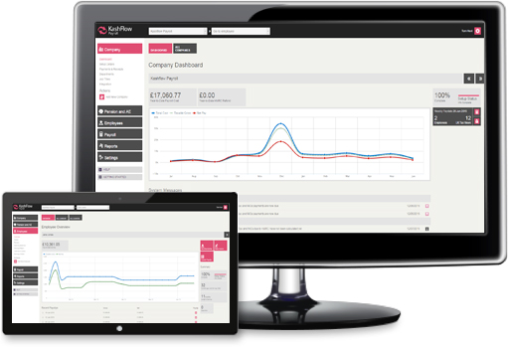

Contents

Introduction

Introduction ……………………………………………………………. 2
Security …………………………………………………………………… 3
Creating a KashFlow Payroll account ………………………. 4
KashFlow Payroll layout ………………………………………….. 6
Changing your password
Integrating with KashFlow ………………………………………. 9
Changing your password ………………………………………… 11
Adding a new company ………………………………………….. 12
Adding a new employee …………………………………………. 17
Automatic Enrolment ……………………………………………… 22
Payroll Run ……………………………………………………………… 32
Reports …………………………………………………………………… 39
Subscriptions

Thank you for choosing to use KashFlow Payroll. To ensure you get the maximum benefit from KashFlow, we strongly advise that you read through this guide to familiarise yourself with all of the features available.

KashFlow Payroll is an online payroll system that allows you to easily manage day to day payroll responsibilities including RTI submissions, Automatic Enrolment, statutory payments including managing sickness and generating and sending online payslips.

Aimed at small businesses and start-ups, as well as accountancy professionals wishing to run multiple payrolls, KashFlow Payroll has been designed with the small business owner in mind. Unlike more complex payroll software – KashFlow Payroll is incredibly easy to use. To keep your data secure we use the same security and encryption techniques that are used for internet banking.

We are always happy to hear from you with regard to suggestions for new features or criticisms of how the system currently works. If you have any comments to make please join our online user community, KashFlow Canvass at http://www.kashflowcanvass.com

Security

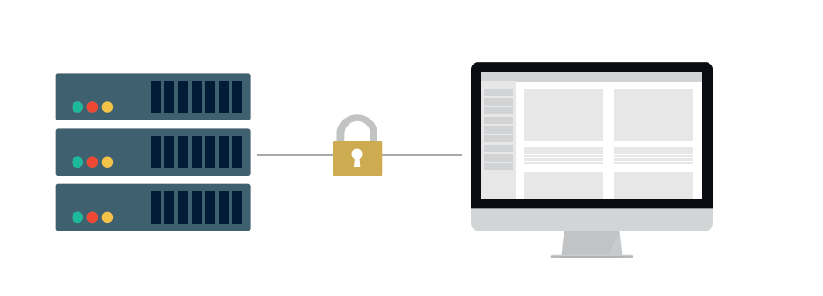
We know that security is a primary concern for any business when it comes to storing and sending sensitive information on the internet. For that very reason we employ SSL encryption techniques. This is the same method of encryption used by banks for their online banking systems and by ecommerce websites that take credit card information.

Once you are logged in to your account all data transferred between the server and your computer is encrypted so that it can’t be read by anybody else.

We also employ additional security methods during the log on process to make sure that any virus or other rogue software on your computer isn’t able to detect your login details. In terms of physical security – the servers that run the KashFlow application are housed in a highly secure facility in the Western area of London and in the North of England. The servers have the protection of security barriers, 24x7x365 monitoring by on-site personnel to include visual verification of all persons entering the building, CCTV video camera surveillance and a security breach alarm provides the control room with information.

Access to the buildings, data floors and server area is via individually programmed Proximity Access Cards (PAC), usage of the PAC is logged centrally by time and date. The cards cannot be used by anyone else, whenever someone swipes their card tag over the sensors to gain access to the building, their digital photograph will be displayed on our security systems which are continuously monitored by our on-site technicians. The technicians will then verify the information and only when satisfied, allow access.

To ensure that nobody else using your computer can access your information, please make sure that whenever you are finished using the system you click on the ‘Log Out’ button located towards the bottom of the left menu.
If you have any specific concerns regarding security we will be happy to address them. Please contact support@kashflow.com with your questions.
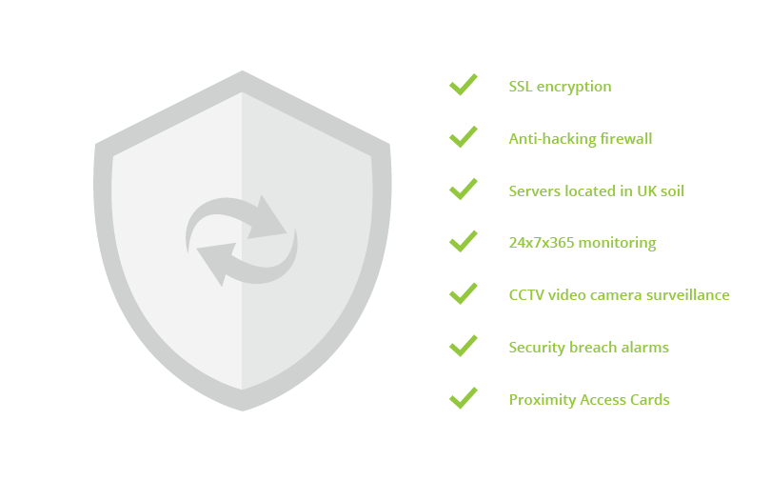

Creating a KashFlow Payroll account

System Requirements

We support the following web browsers.
Internet Explorer 8 and above *
Mozilla Firefox 9 and above
Safari 5 or greater
Google Chrome
iPad or Android tablet web browser
If you are not sure whether you’re using a supported web browser, click here to check using whatbrowser.org.
* Note that Internet Explorer 7 users can use KashFlow Payroll, however they may have some display issues.

Javascript Turned On
KashFlow Payroll uses Javascript to make your experience of our system smoother and faster. It is not possible to use KashFlow Payroll without having Javascript switched on. If you try to log into KashFlow Payroll without Javascript switched on, you will see a warning message.
If you are unsure about how to switch on Javascript, or would like to check, visit enable-javascript.com.
Cookies Enabled
KashFlow Payroll uses cookies to enable login. If you do not have cookies enabled in your browser you will not be able to sign in to KashFlow Payroll and will need to adjust your browser settings.
The following suggestions will help you get the most out of KashFlow Payroll:
- Use the latest browser (we like Chrome for the best browsing experience).
- Ensure that you have the Adobe PDF Reader installed.
- If you use Firebug, disable it during your KashFlow Payroll session for better page performance.
- To view reports in Excel format you will need either Microsoft Office’s Excel installed or a compatible free viewer from Open Office.
- Check your screen resolution is at least 1024 x 768
- Trouble Connecting
- If KashFlow Payroll isn’t loading, or times out, it might be that you are having trouble connecting to the Internet. Here are a few things to try:
In the same browser, check that you can get to other websites, e.g. www.google.com.
If you can connect to the Internet but are still having trouble try shutting down/closing the browser completely and opening it or even another browser and trying again.

Creating a KashFlow Payroll account

To create a KashFlow Payroll account go to go.kashflowpayroll.com and click on the sign up link in the top right hand corner of the screen.
At this stage, you will be asked to enter your name, email address and telephone number. Please note that this email address will be used as your login email address. You can change this at a later date.
You must read the Terms of Use at this point before being allowed to continue. Once this is done, you will be sent an activation email that will ask you to create a password for KashFlow Payroll. Your password must contain letters, numbers and one character that is not a letter or a number, for example an item of punctuation such as a question mark.
Please note, if you do not receive your activation email within 60 seconds of sign up, please check that you have entered a valid email address or use the link at the bottom of the sign up screen that will re-send your activation email
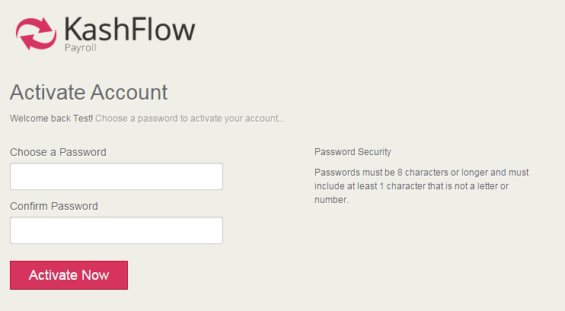

Upon successfully creating your password, you will be taken to the KashFlow Payroll setup wizard to add your first company, alternatively you can explore the system using the free demonstration company
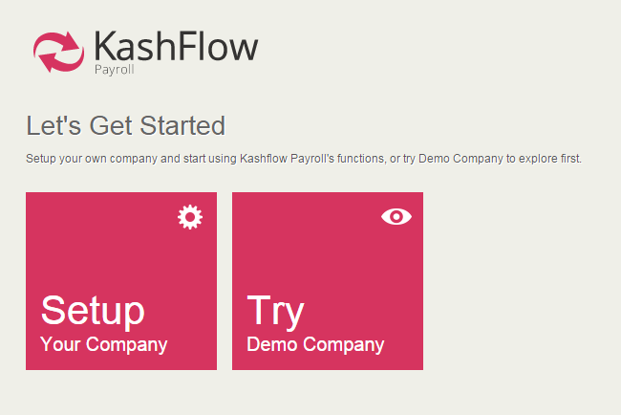

KashFlow Payroll layout

KashFlow Payroll is simply organised with a main menu or navigation area down the left-hand side and your working context – which company and employee you’re currently working on – across the top.
Company and Employee Selection
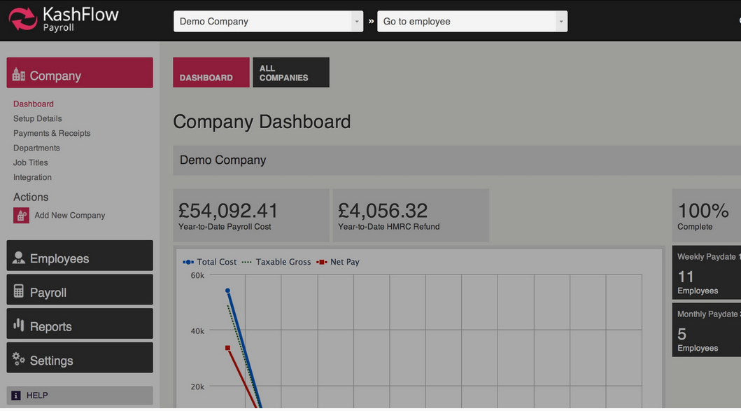
Using the dropdown menu at the top of the screen, you can quickly select which company you would like to work on and then which employee you wish to view
The first box on the left shows the current company in context.
The second box shows the current employee whose data you will be seeing on any page in the Employees section or when looking at payslips.
The name and gear icon to the right give you quick access to your own user profile and system logout.
Using the employee and company context menus
These menus play a special role in how you use KashFlow Payroll and help you to quickly move around the system to complete your payroll.
Company Context
Click the box to see a drop-down list of companies you have set up in KashFlow Payroll, then click a company name in the list select a different company to work with or change to Demo Company.
Employee Context
When you change employee by clicking on this box and selecting a different employee, if the current page contains employee related data, you will stay on the page but see information for the employee you’ve changed to. However, if you are on a non-employee related page (e.g. Company Dashboard) selecting an employee in this box will take you to that employee’s dashboard.
Also note that the employee context drop-down list is sorted alphabetically by employee name and only ever shows the first 18 current employees. If you have more employees than that in KashFlow Payroll, just start typing any part of the employees name and the list will change to show employees matching the text you type.
The main menu for KashFlow Payroll is down the left-hand side.
KashFlow Payroll layout

Company
Contains all company-related data and actions for the company you are currently working with.
Employees
Employee specific dashboard, setup information, absences, statutory leave and arrestment orders. Note that whenever you are in the employee area, you will see data for the current employee in context.
Pension and AE
Configure your pension schemes and setup Automatic Enrolment. View all communications to be sent to employees and add additional pension schemes
Payroll
Your payslips, current and past pay dates, and RTI filing records.
Reports
Generate payroll, employee, pension and statutory reports such as P45s here.
Settings
Your account and billing settings as well as billing history.

Tabs
Many pages have one or more tabs near the top, as illustrated below. These tabs provide access to pages within a section.
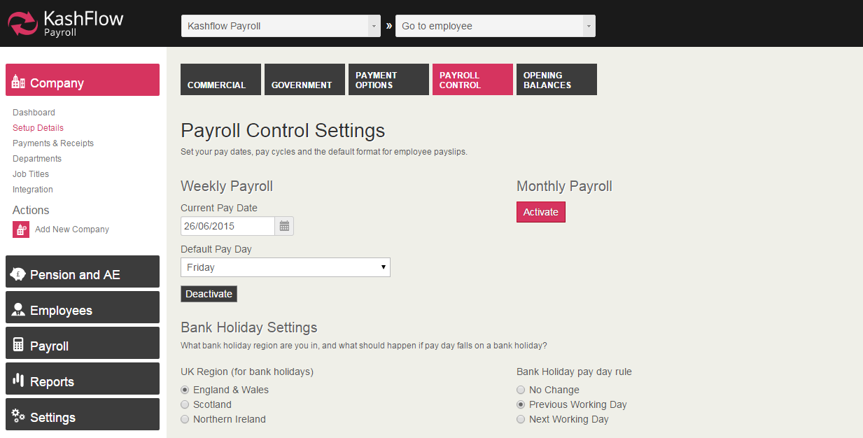

Dashboard

Dashboard
There are two main dashboards, the company dashboard and the employee dashboard.
The company dashboard screen is your “home page” for that organisation within KashFlow Payroll. Each company that you have set up has its own dashboard. From here you can go directly to the current pay date and manage payslips, see a graphical overview of your last 12 months of payroll, and find system messages alerting you to important events within your companies’ payroll.
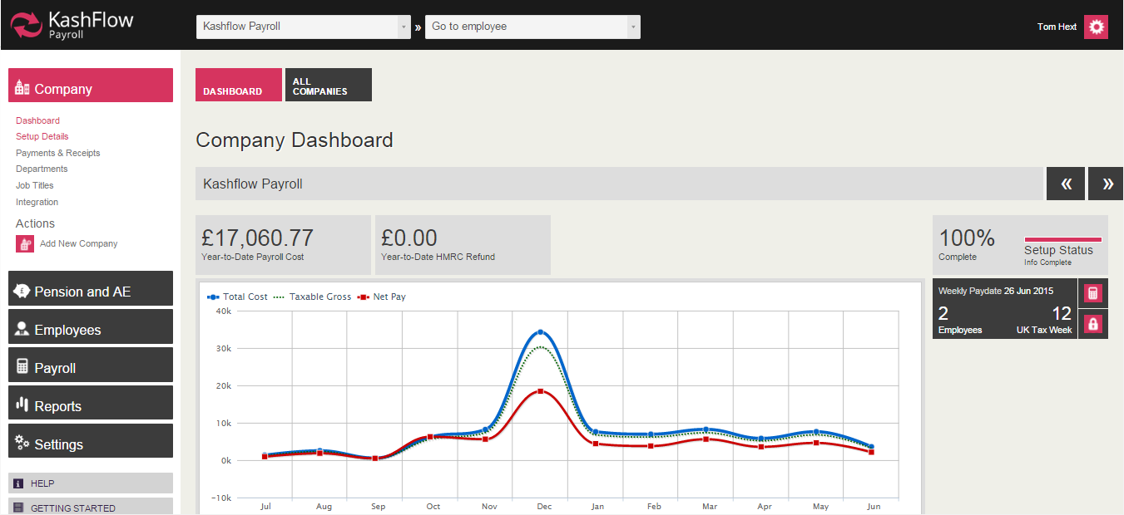
The employee dashboard is specific to each employee (i.e. you have a dashboard page for each employee you have in KashFlow Payroll). The employee dashboard gives you the Year-To-Date net pay figure, a graphical summary of recent pay to an employee, quick view-and-print of their last 6 payslips and a brief summary of employee statistics.

The following actions are also available for you from the employee dashboard:
- Go to current payslip
- Set employee’s directorship (appoint or dismiss)
- Make employee a leaver
Note that these actions change if the employee you are looking at is already a leaver:
- Go to leaver’s last payslip
- Rejoin this leaver as an employee
- Download / print a P45

Integrating with KashFlow

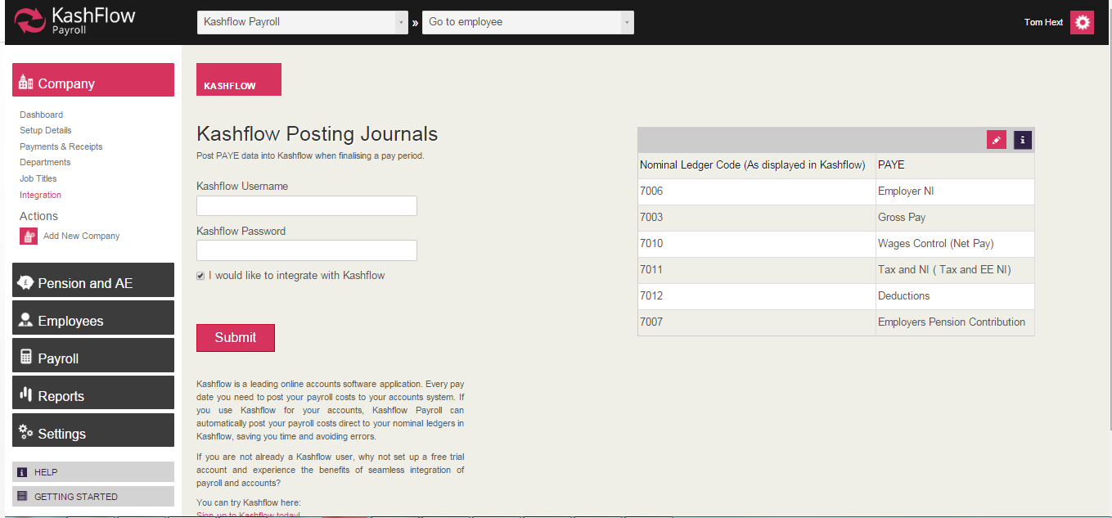
First you need to go in to KashFlow and make sure you have the API (Application Programming Interface) enabled. You can find this in Apps> API Settings (top right hand corner) then just tick Enable. This will then open your account to another software to access it through an API link.
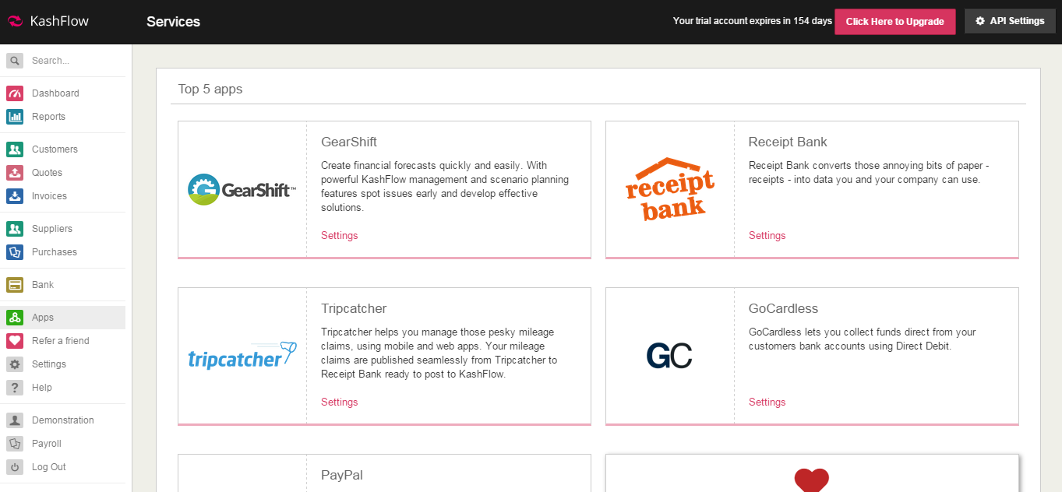

KashFlow Payroll
Once you log in to KashFlow Payroll, just go to Company> Integration> you will then to see where to enter your KashFlow Username and Password.
First you’ll need to tick I Would Like to Integrate with KashFlow then enter your KashFlow username and password.

This will then integrate in to KashFlow straight away and you can start posting immediately.

Integrating with KashFlow

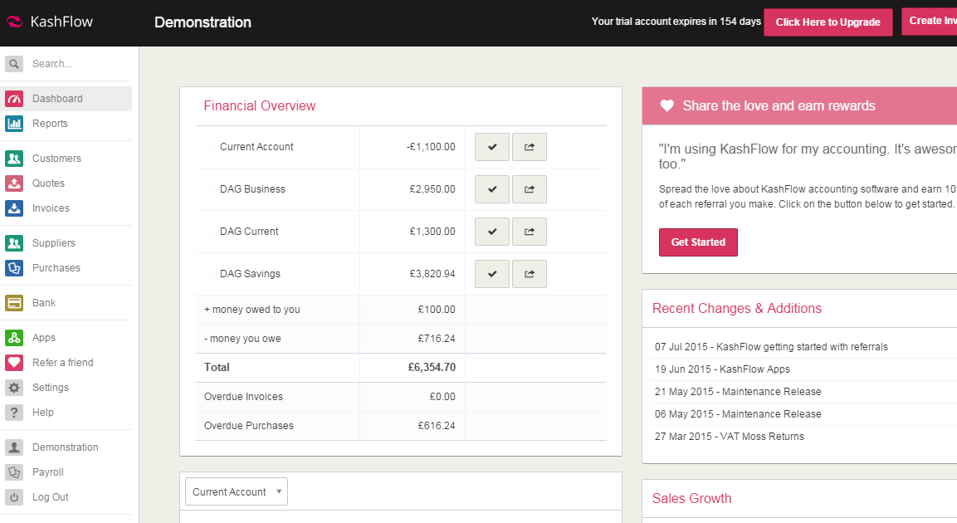
When you set up KashFlow you will have to be on the Business + Payroll package. You can check this in Settings> Manage Subscription. If you want to switch then see how to do this here

When you are on your Business + Payroll package you can integrate to KashFlow Payroll. This is accessible by clicking the Payroll tab on the menu bar in KashFlow.
You will then be prompted to either set up an account or sign in to an existing account if you already created on direct with KashFlow Payroll.
Once you have supplied your details. We’ll log you straight in to KashFlow Payroll where you can start posting.

What Happens Once You’re Integrated
You can then run your Payroll in KashFlow Payroll then we will then post a journal in to your account showing your Payroll. You can find this under the Journals tab. You will notice the entries are made against the codes you selected when integrating KashFlow Payroll to KashFlow.
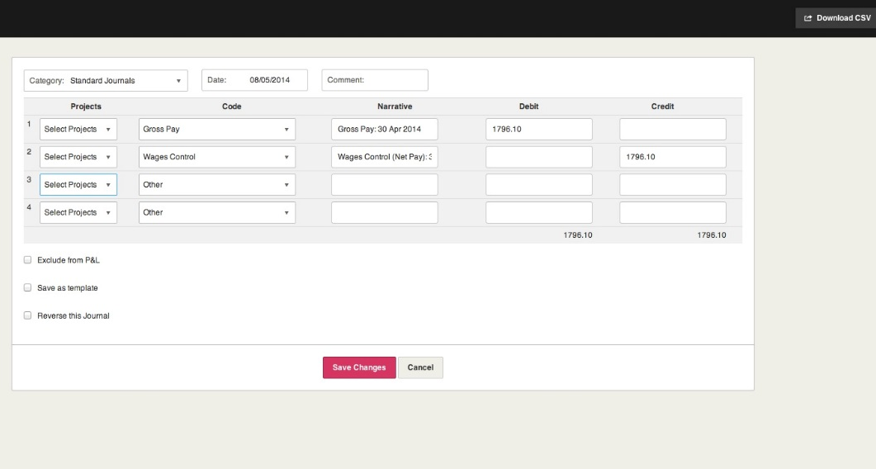
It’ll look something like this…

KashFlow or KashFlow Payroll will NOT make the payment to your employees for you. You must do this manually through your Bank.

Changing your password

If you are looking to change your password for your KashFlow Payroll account you can do so here.
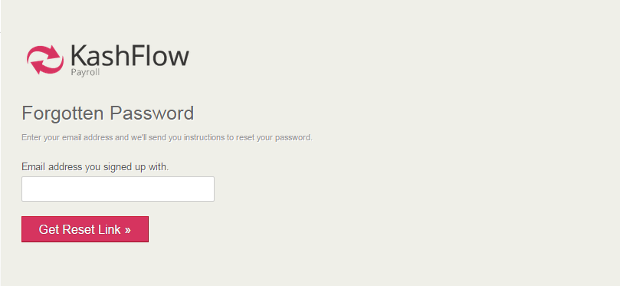
You will then need to enter the email address you use to sign in to KashFlow Payroll.
Your new password will be sent to your email immediately.

Haven’t received your new password?
If for any reason you don’t receive the link then ensure you check your spam/junk folders.
Still not there? Contact KashFlow Support by emailing support@kashflowpayroll.com.

Adding a new company

Required Information
To set up your company with sufficient information to process your payroll, you’ll need to collect a few key pieces of information.
You can enter just the basic information on the first screen of adding a new company to get going; however we recommend that you fully complete company setup to avoid having to return to fix things later.
After setup, you can change or complete any information you may have left out using Company » Setup Details from the left-hand main navigation.

Required Setup Information
Before you can use KashFlow Payroll to create payslips, process pay runs, and pay employees, you will need to complete set up for your company.
If you already have payroll software that you are moving from, you should be able to collect this information from your existing software’s setup screens.
If you are unsure about where to find any of the data required for company setup, check with your accountant, HMRC, or contact support.

Information you’ll need
- The correct legal name of your company.
- Your current weekly and/or monthly pay date. If you pay employees each week, enter your next pay day. Likewise if you pay monthly. You may use both pay frequencies at the same time in KashFlow Payroll.
- Employer PAYE Reference. Your office and reference number that you can find on the yellow PAYE Payslip booklet supplied by HMRC.
- Accounts Office Reference. You will find this 13 character reference number on the PAYE payment booklet or letter supplied by HMRC, printed in the format 123PA12345678.
- Corporation Tax Reference (optional). Normally applies to limited companies and can also be called the Company Unique Taxpayer Reference (UTR) and will have been issued by HMRC. Can be found on the ‘Notice to deliver a company Tax Return’ (form CT603). It may also be found on other documents issued by HMRC.
- Self Assessment Unique Tax Reference (optional) – Normally applies to sole proprietors or partnerships and used in RTI submissions to help HMRC identify a sole trader. If you registered with HMRC for Self Assessment, enter the reference number they supplied.
- Contracted Out Number (optional) – Required if you operate an occupational contracted-out pension scheme. Sent to you by HMRC when you set up your scheme, and which you will have entered on form P35 when completing your past Annual Return.

Adding a new company

- Your banking information (optional). If you plan to pay any employees by electronic transfer (BACs) you will need your BACs format, bank account name, number and sort code to hand.
- Opening balances.

Commercial Information
In the Commercial information tab, provide KashFlow Payroll with contact details for your Company, such as the Address to display on payslips.
Field Help:
Business Type
Note that this is an optional field, but gives us an idea of what kind of employer you are.
Address
KashFlow Payroll is looking for the address of your company. This will appear on Payslips.
Additional Address Lines
Any additional address lines you have.
Postcode
The postcode to the above address

Telephone
Telephone number of your company.
Government Settings
Each Company in KashFlow Payroll represents a PAYE Scheme and HMRC will have given you some references and numbers to help them identify you in the RTI submissions.
References
Try and complete as many of these references as you can find;
- Employer PAYE Reference: You will find this reference on the yellow PAYE Payslip booklet supplied by HM Revenue & Customs (HMRC).
- Accounts Office Reference: You will find this 13 character reference number on the PAYE payment booklet or letter supplied by HM Revenue & Customs, printed in the format 123PA12345678. References that are not 13 characters long require zeros (0) entering after the two letters to make it up to 13 characters e.g. 123PA00045678
- Corporation Tax Reference: This reference, also called the Company Unique Taxpayer Reference (UTR), is ten digits long and applies to limited companies. You will find this reference on the ‘Notice to deliver a company Tax Return’ (HMRC form CT603).
- Self Assessment Unique Tax Reference: This reference is ten digits long and usually applies to sole proprietors or partnerships. You will find this reference on a Self Assessment return that you have made to HMRC.
Adding a new company

- Tip: Prior to RTI this reference was written on paper forms in the following format [123 12345 67890 A]. Only the ten numbers in italics, but without the space, are the Tax Reference. The first three numbers represent the tax office and the ‘A’ is a remnant of the CT payment system.
Contracted Out Number
This is required if your company has a certified contracted out pension scheme. All ECONs begin with the letter “E”.
Are you eligible for Small Employers Relief?
An employer qualifies for SER if their Class 1 NICs fall below a certain level in the Tax Year. HMRC or your accountant should be able to tell you if you qualify for Small Employers Relief but after a year of using KashFlow Payroll you will be advised if you qualify automatically. Small Employers Relief means KashFlow Payroll will offset your monthly payments to HMRC with a compensation or recovery amount when you make any Statutory Payments such as Statutory Sick Pay or Statutory Maternity Pay.
Enable Online Filing
Normally you would leave RTI Filing switched on so that KashFlow Payroll makes RTI submissions for you online and on time. There are no buttons to press or procedures to follow; KashFlow Payroll simply files everything required online when it is needed.

An FPS submission is required on or before every Pay Date and KashFlow Payroll will perform these automatically for you when you finish with a Pay Date. You should only disable RTI Filing if you are sure RTI submissions have already been made for the Pay Dates you are closing. Examples of why you could turn RTI Filing off are:
- A separate system is performing the RTI submissions.
- Historical data is being entered in to KashFlow Payroll so actual RTI submissions are not required.
- KashFlow Payroll has already made the RTI submissions because the user has performed the Rollback Action to an earlier Pay Date. A Rollback generally disables RTI Filing and any amendments to the earlier payroll will be reflected in the Year To Date figures of the next normal FPS when RTI Filing is enabled again.
- If RTI Filing is disabled you must remember to turn it on again when processing the current Pay Date and KashFlow Payroll will remind you to do so.
HMRC Online Filing Credentials
- When KashFlow Payroll makes an online RTI submission for you, it needs to login to HMRC with a user name, password and some contact details (your ‘credentials’). If you have ever done any online filing before then you should already have the necessary credentials and should enter them here. If you do not have any credentials, or just don’t feel like typing them in, you can use KashFlow Payroll’s credentials.

Adding a new company

Payment Method
- Choose a default method to pay your employees. You may override this setting per employee.
- Payment options
- This company setup tab is all about how you pay your employees.
You can pay your employees by
- Cash
- Cheque, or
- Electronic Transfer (for example, by BACS)
- Other (for example, if you use your online banking system)
Banking Information
If you pay by Electronic Transfer then KashFlow Payroll needs to know your bank details in order to create the appropriate payment file for you. For building societies you may need to enter your Building Society Roll Number in the BACS Reference box.
When you close a Pay Date you will be able to download a BACS file for a specific Electronic Payment Type, such as
- Barclays Business Master
- HSBCnet
- Lloyds Link
- etc

You can then import the BACS file to your banking software to pay your employees directly, without having to rekey any information.
Payroll Control Settings
This company setup tab tells KashFlow Payroll how you want your Pay Dates to be set because every time you close a Pay Date, KashFlow Payroll will create the next one for you. For example, you may want your weekly Pay Dates to be on every Friday, or your monthly Pay Dates to be on the 25th of the month or earlier if this is a weekend or bank holiday.
Payslip Format and Delivery
You can choose from a number of layouts for the employee payslips and how you generally want payslips to be delivered. For example, you may like to print payslips yourself or use the Employee Self Service facility.
Employee Self Service
KashFlow Payroll runs over the internet, so your employees can login and get what they need from KashFlow Payroll. Employees can collect their own current or historical payslips (sometimes called electronic payslips) so when you have closed a Pay Date there is nothing to print or deliver – saving you time and paper.

Adding a new company

Opening Balances
Opening Balances tell KashFlow Payroll what the Year To Date figures were before you started using KashFlow Payroll, so you only need Opening Balances once for the Year that you start using KashFlow Payroll and only if you processed payrolls earlier in the year. KashFlow Payroll sets the Year of the opening Balances for you.
Before you pay employees the first time through KashFlow Payroll
It is best to enter the Year To Date compensation and recovery amounts from your previous payroll system before you finish your first Pay Date in KashFlow Payroll.
Zero Values
Opening Balances can all be zero if
- your Company is not eligible for Small Employers Relief (as there wouldn’t be any compensation or recovery figures in the first place)
- you did not process any payroll for this Company earlier in the year (ie you are a new Company and have not paid anyone before)
- you start using KashFlow Payroll in the first week or month in April (the easiest time to start using a new payroll system)
You should now have set up your company in KashFlow Payroll successfully

Adding a new employee

Required Information
Before you can use KashFlow Payroll to create payslips, you must have at least one employee in your company for whom you have completed all the required setup fields.
If you already have payroll software that you are moving from, you should be able to collect this information from your existing software’s employee information screen.
- Join date – Date the employee started their current period of employment with your company.
- Employee address and postcode
- Current marital status and date of birth
- Tax code – Normally you’ll get this from a P45 form for a new starter or your previous payroll system. If you don’t have one you can temporarily use the current emergency tax code, which is the default supplied by KashFlow Payroll.
- Tax calculation method– Normally you’ll get this from a P45 form for a new starter or your previous payroll system.
- National Insurance Number (NINO) and Category – If you don’t have this information to hand (e.g. on a P45), or you can request it from HMRC.
- Employee banking information (optional) – If you plan to pay this employee by electronic transfer (BACs) you will need their bank account name, number and sort code to hand.
- Opening balances.

Basic Information
After setting up your first Company you will be guided through the process of entering your first Employee. The first step of the setup process asks for basic information like the Employee Name and Join Date.
KashFlow Payroll needs to know if the employee is an actual new starter (also called a joiner) or if you’ve paid them before using some other payroll system. To find employee details; new starters usually have a P45 from their previous employer whereas employees that you have paid before will have details in your previous payroll system.

Starter Declaration
If you are entering an actual new starter then HMRC needs to know what kind of starter they are; please select A, B, C or ‘unknown’ if the employee has not given you enough information. The following factors determine exactly what Tax code you need to use for the new starter:
- Do they have a P45
- Does the P45 relate to this year, last year or an even old year
- Is the Tax Code on the P45 BR, 0T or D0
- Is the employee starting on or before 24th May or after 24th May
It is up to you to enter the correct Tax Code on one of the other tabs below, but KashFlow Payroll will set a default for you as best it can. Full HMRC guidance on setting the Tax code of a new starter can be found here www.hmrc.gov.uk/payerti/employee-starting/new-emp-info.htm
Adding a new employee

Directors
If the employee is, or has been, a director since 6th April then KashFlow Payroll needs to know the date that the directorship started (and ended if in the current Tax Year) and the NIC Calculation Method (National Insurance Contributions). A director can chose to have their NICs calculated in one of two ways:
- As Director: NICs are calculated cumulatively, that is to say on a Year To date basis like Tax normally is.
- Like Employee: NICs are calculated non-cumulatively; which is the way NICs are normally calculated for employees. However, in the last payment for the year (or the directorship itself) KashFlow Payroll will automatically recalculate NICs on a cumulative basis as required by HMRC.

Personal Information
In order to help HMRC identify an employee, especially a new starter, their full name and correct date of birth is required.

Known As
It is best to use the First Name and Last Name boxes to hold the full and correct employee name, as found on the birth certificate or passport, for example ‘Antony Trenker’. The full name will be used on Payslips on when making RTI submissions to HMRC. The Known As box can be used for the informal or nickname of the employee, as used within the company, for example ‘Tony’.

Contact Details
This employee setup tab gives KashFlow Payroll some address and contact details about your Employee, including telephone numbers.

Employee Address
Please note that HMRC require at least two lines of an employee’s address. Therefore, you must enter at least one additional address line in the “Additional Address Lines” text area.

Employment Settings
This employee setup tab reflects some details of the employee contract and the nature of their employment, such as Job Title or Directorship start and end dates.
Job Title
You will need to enter the employees Job Title or on the right type your own.
Department
New Departments are setup under the Company menu and an employee can be assigned to one Department reflecting the main cost centre that their employment is in. Payroll figures can be analysed by Department from the Reports menu and individual Pay Items can even be assigned to a different

Adding a new employee

department, for example, when an employee does some overtime to help another Department.
Leave Date
If the employee has left the Company then their Leave Date is shown. To set an employee as a leaver use the Leaver Action from their Dashboard.
Director Start and End Date
If the employee is or was a director of the Company then their directorship Start and End Dates are shown. To start or end a directorship use the Set Directorship action from their Dashboard.
Government Settings
Each Employee in KashFlow Payroll will have been some references and numbers to help them identify them to HMRC and in the RTI submissions. Furthermore, each Employee will be assigned some codes by HMRC to enable Tax and National Insurance Contributions (NICs) to be calculated correctly.
Tax Code
You are responsible for entering the correct Tax Code and the correct Tax Calculation Method. Full HMRC guidance on setting the Tax code of a new starter can be found here www.hmrc.gov.uk/payerti/employee-starting/new-emp-info.htm
Student Loan

Click ‘Yes’ for Student Loan deductions to appear on the Payslip. KashFlow Payroll knows how to calculate Student Loan repayments and whether the employee is exempt from paying them or not (based on earnings).
National Insurance Category
You are responsible for entering the correct NI Category
National Insurance Number
This is one of the key ways that HMRC uses to identify an employee; also known as a NINO. It is important that you do not enter a fake NINO. If you do not know the employee’s NINO then you can use the Employees National Insurance Number Trace form from HMRC.
Payment Options
In order to process Payslips, deliver them and actually pay an employee, KashFlow Payroll needs a range of details.
Pay Cycle
KashFlow Payroll supports employees paid on a regular repeating weekly or monthly Pay Cycle. If you cannot see the option you want, make sure that you have specified a weekly or monthly Pay Date for the Company.
Is employee paid intermittently?
Adding a new employee

This field is included in RTI submissions but you can simply set this to ‘No’ unless you know that this employee does not always get paid (commonly known as a casual labourer). KashFlow Payroll will detect when this option needs changing so you can’t go wrong.
Hours per Week
Please enter the normal contractual hours that the employee is expected to work according to their contract – not to be confused with the actual hours worked in any particular week. KashFlow Payroll will use the Hours per Week to calculate an employee’s hourly Rate if you only supply a weekly Rate.
Payslip Delivery Email Address
You can choose to print payslips for the employee or get them to use the Employee Self Service facility. The employee’s email address is used for their Self Service login and to notify them when a new payslip is ready to collect.
Employee Self Service
KashFlow Payroll runs over the internet, so your employees can login and get what they need from KashFlow Payroll. Employees can collect their own current or historical payslips (sometimes called electronic payslips) so when you have closed a Pay Date there is nothing to print or deliver – saving you time and paper.

Opening Balances
The Employee Opening Balances tell KashFlow Payroll what the Year To Date figures were before you started using KashFlow Payroll, so you only need Opening Balances once for the Year that you start using KashFlow Payroll and only if the employee was paid by you earlier in the year.
It is important to enter these Opening Balances from your previous payroll system before making a Payslip for the Employee because the Opening Balances may affect the Tax and National Insurance Contributions (NICs).
Opening Balances can all be zero if your Employee is simply a new starter (and therefore was not paid by you earlier in the year)
you did not process any payroll for this Company earlier in the year (ie you are a new Company and have not paid anyone before)
you start using KashFlow Payroll in the first week or month in April (the easiest time to start using a new payroll system)
Previous Payroll
If you have paid this employee before please enter the Employee Reference used by your previous payroll system. This will help HMRC to match this employee in the first RTI submissions that KashFlow Payroll makes. Note that you will only see this field if you indicated during employee setup that you had paid the employee before.

Adding a new employee

Working Pattern
Once you have created an employee you must tell KashFlow Payroll what their normal working pattern is for statutory payment purposes. Based upon this information, KashFlow Payroll will automate various processes.
Enter the days that an employee usually works during a working week. If this is irregular, enter a usual pattern or a matching number of days within the week.

Automatic Enrolment

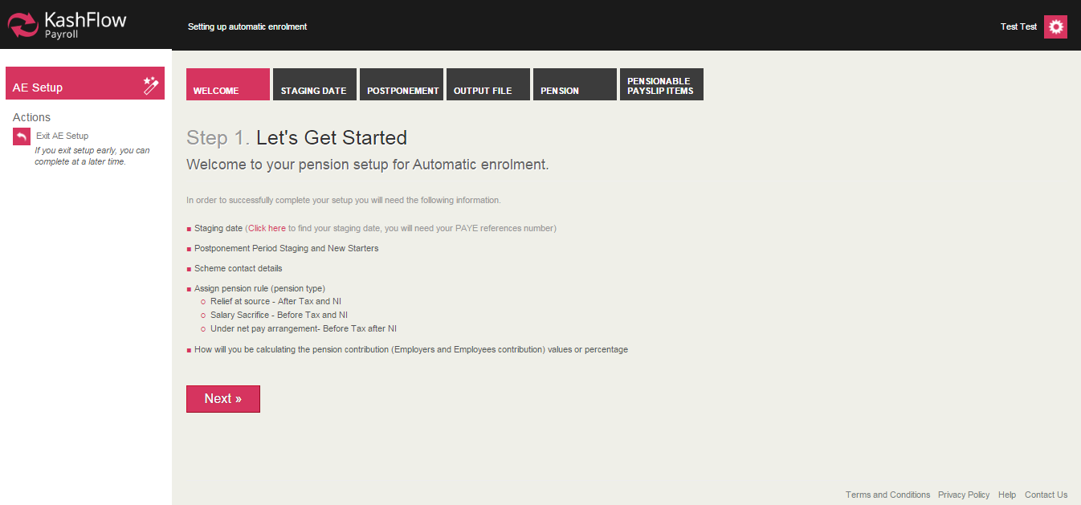
What is Automatic Enrolment?
Automatic Enrolment has been introduced as part of Workplace Pension Reform and affects every small business with one or more employees. Every employer will need to provide a qualifying pension scheme for their employees, assess and enrol them within each payroll run and generate communications to be sent to both employees and their chosen pension provider.
Further information can be found at www.kashflow.com/autoenrolment

Adding a pension scheme
Using the AE Setup wizard, enter details of your chosen pension scheme, contribution amounts and staging date/postponement arrangements
Please ensure you have the relevant information available. The Setup Wizard will direct you to the relevant source of information, should you require any further details please visit www.thepensionsregulator.gov.uk

Automatic Enrolment

Staging Date
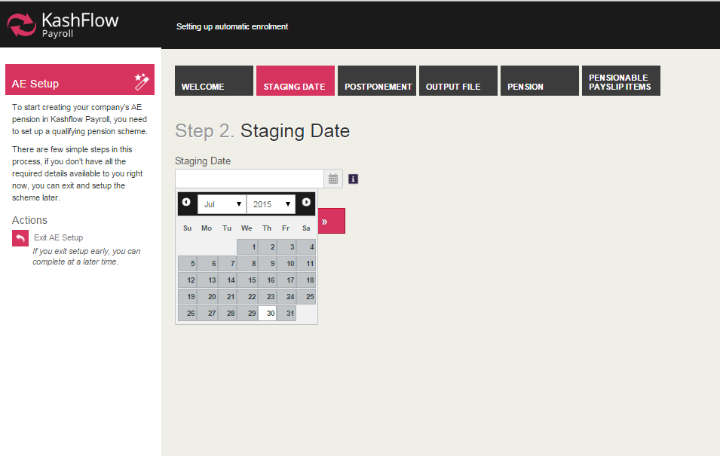
Enter your staging date, excluding any postponement period. You can locate your unique staging date by entering their PAYE reference number at www.thepensionsregulator.gov.uk. The staging date is based upon the total number of employees in your PAYE scheme.

Postponement
Enter desired postponement period at staging date, for new starters and for employees that become eligible at a certain point but should not remain so (for example, if an employee becomes eligible due to an irregular rise in wage but should not be enrolled straight away as following wage will drop back below threshold).
For full details on postponement, deferral and contribution amounts please visit www.thepensionsregulator.gov.uk
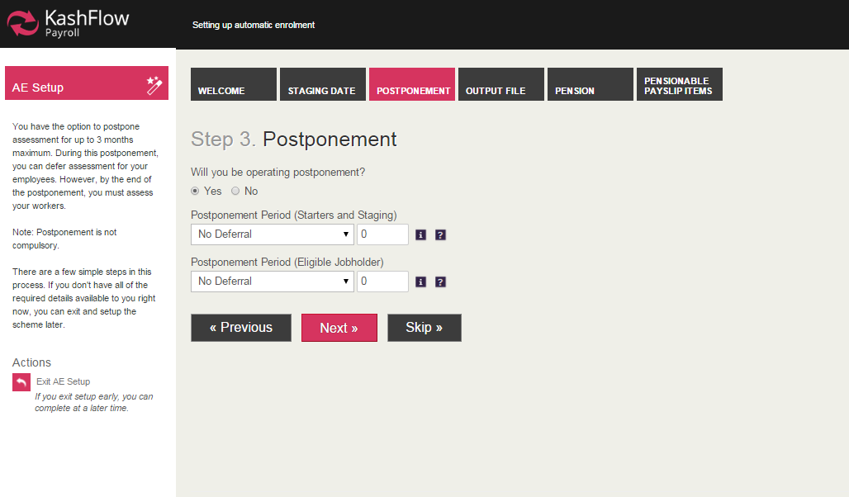

Automatic Enrolment

Output File
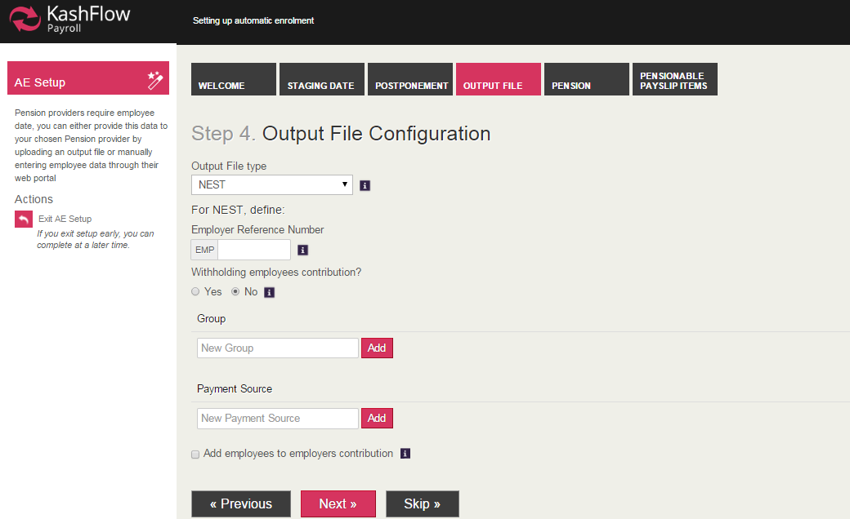
Select which pension provider you will be using to correspond to the output file in KashFlow Payroll. Depending upon which output file format is selected, you will then need to enter additional information that will be provided by the pension provider. In this example, we use

Pension
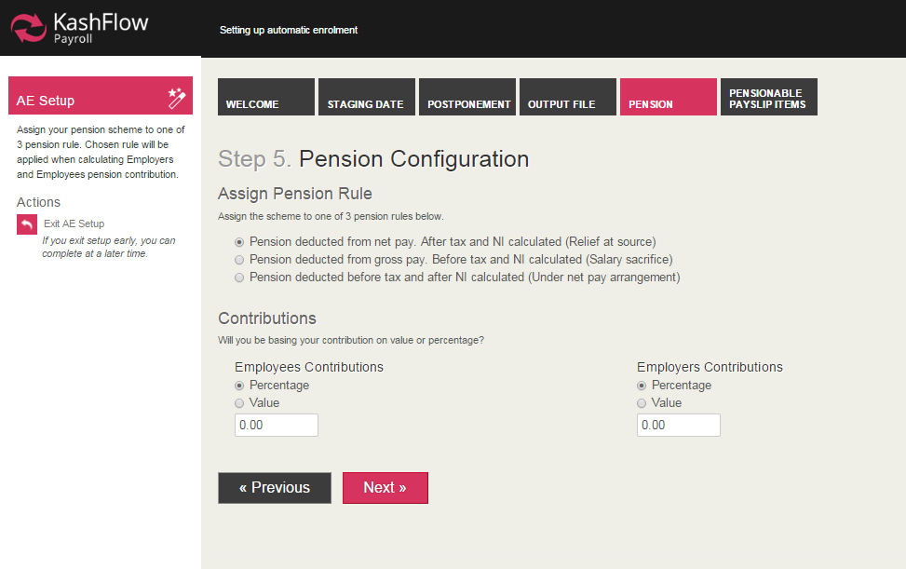
Add details of new qualifying pension scheme. A qualifying pension scheme must comply with all areas of automatic enrolment legislation, an existing pension scheme may not necessarily be qualifying. For further information on qualifying pension schemes, please visit www.thepensionsregulator.gov.uk/employers/does-your-existing-scheme-qualify.aspx

Automatic Enrolment

Pensionable Payslips Items
Choose which pension rule you wish to assign the pension scheme to and enter contribution for employee and employer
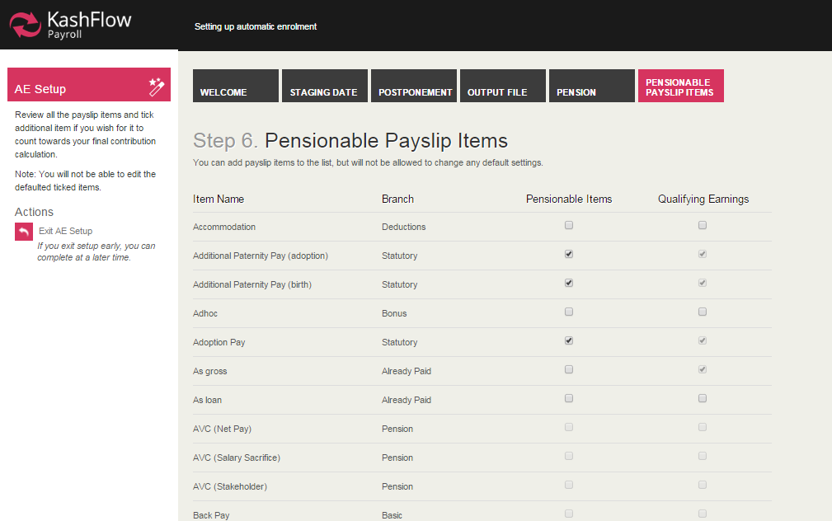
Before continuing, confirm that your pension scheme is a qualifying scheme (see step 4), meets the requirements of automatic enrolment (contribution levels, postponement etc) and is to be taken as the default scheme for all new employees

Select payslip items that are pensionable and those that are qualifying earnings. For example, a Christmas Bonus may form part of the total payslip but does not contribute towards the required earnings threshold for that employee. Similarly, items on the payslip may not be pensionable and therefore cannot have contribution amounts removed from them

Employee Details
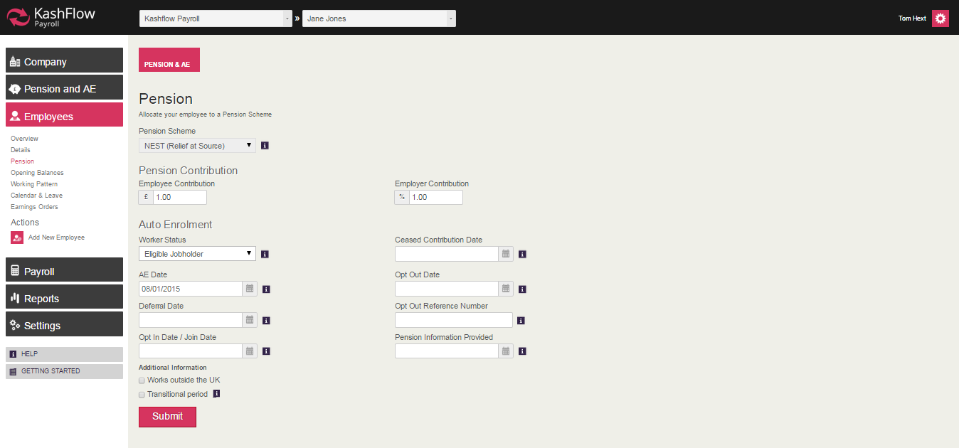
Edit an individual employees pension arrangements, including pension scheme, contributions and opt out settings. If an employee does opt out, they must obtain an opt-out reference number that needs to be entered into this area.
Automatic Enrolment

Assessment of Employees
Automatic assessment of employees is carried out within a normal payroll run, once your AE setup is fully complete, based on the criteria listed below;
- Employee is aged between 22 and state pension age
- Employee earns more than £10,000 a year
- Employee works in the UK
Assessment must take place within each payroll run to ensure that any changes in employee circumstance are captured and reflected. KashFlow Payroll will automate this process for you.
Complete a normal payroll run through ‘Payslips & Periods’, ensuring that you are within the correct company and the AE Setup is fully complete. Enter details onto the employee’s payslip as normal and click to ‘Save Changes’, followed by ‘Approve Payslip’. Pension changes

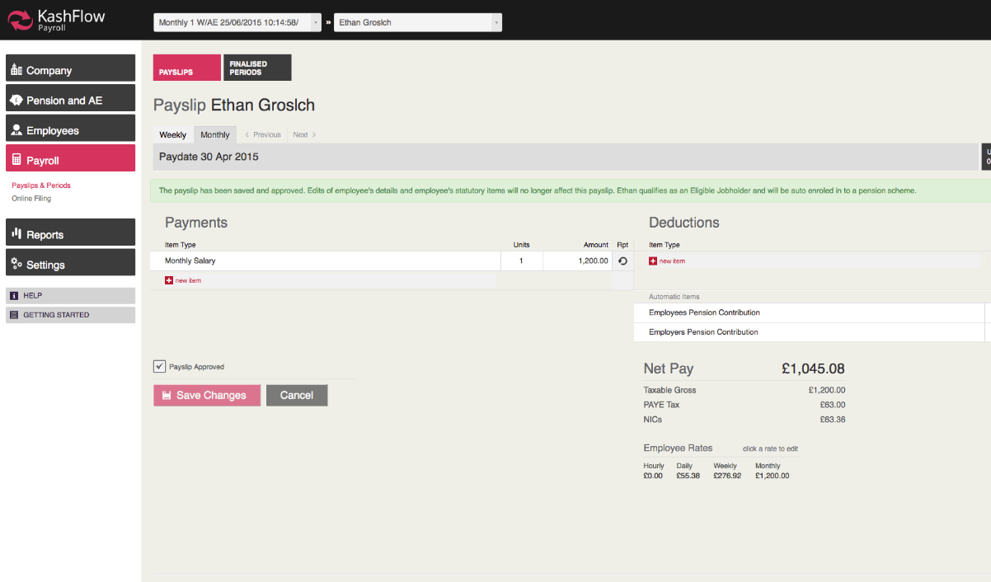

Automatic Enrolment

Communications
In order to remain compliant you must generate pre-approved communications to employees. These can be generated under the ‘Pension and AE’ tab. Once the payroll run has been finalised, communications generated can be viewed and printed to be sent.
There are 4 standard letters that will be generated automatically by the system depending upon your staging date, postponement preferences and the status of your employees;
L0 – Automatic Enrolment is coming
L1 – For Eligible Jobholders
L2 & 3 – Non-Eligible Jobholders and Entitled Workers
L6 – Postponement all Workers
In addition, in the case of postponement, additional letters may be generated with the suffix P to denote postponement versions with adjusted dates.

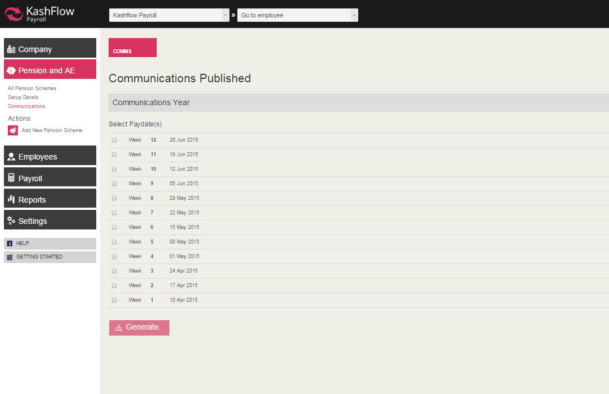
Generating Communications
Based upon the outcome of each assessment, new communications will be generated and held within the communications tab under Pensions and AE. To download communications, select your current pay date and click ‘Generate’.
This will then download the necessary communications to be sent to employees.

Automatic Enrolment

Audit Trail
Comms generated will then be displayed, alongside employee’s AE Status, the Document description and the date that the document was sent. You will then be able to export this information into a report that will show a full audit trail of communications sent.
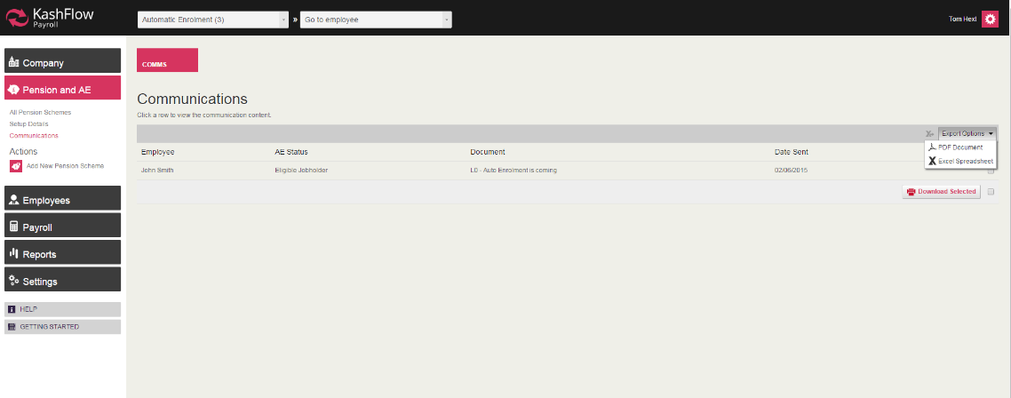
It is important that you have an audit trail available in the instance that you are investigated by the Pensions Regulator who wishes to see proof of your compliance with Automatic Enrolment, in particular your communication with employees.

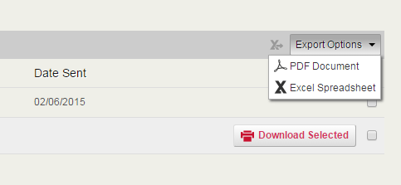

Once you have selected your chosen pay date, you can use the ‘Export Options’ tab to download a full report of your communications generated

Automatic Enrolment

Output Files
Once you have completed each payroll run with Automatic Enrolment, you will need to communicate with your chosen provider to inform them of contributions made, opt-outs, joiners and leavers etc.
You must first configure your system to generate the correct output file.
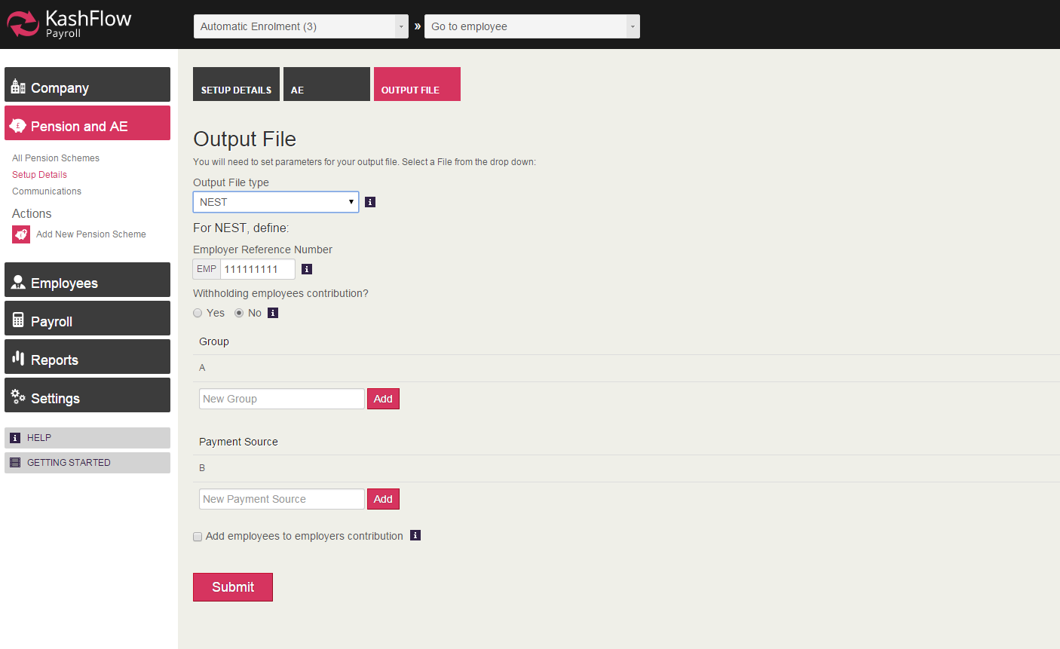
You must also ensure that you have asked KashFlow Payroll to generate your output file when setting up your pension scheme, by firstly filling out relevant details within your pension setup.

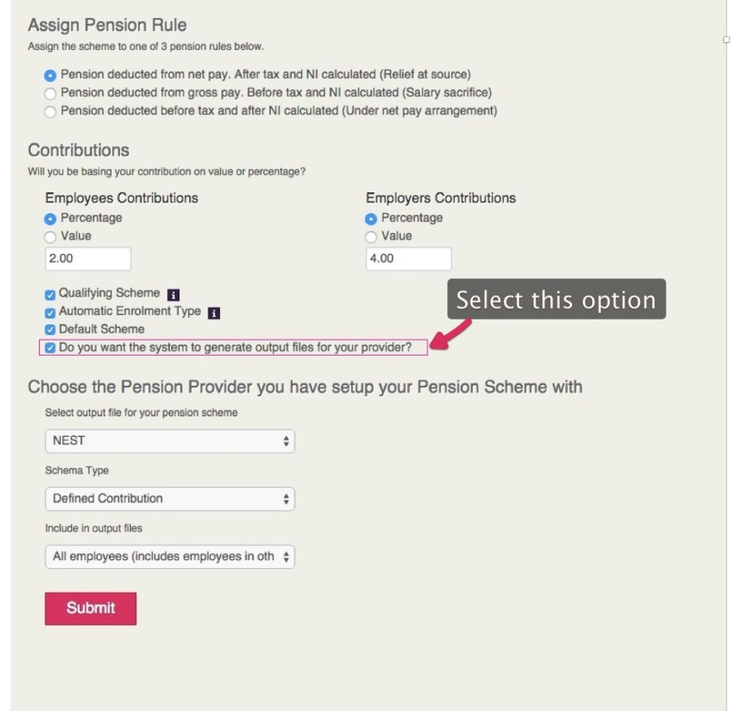

You must then make sure within your pension setup to choose the option to create output files for your chosen provider. If this is not selected, you will not be able to generate output files

Automatic Enrolment

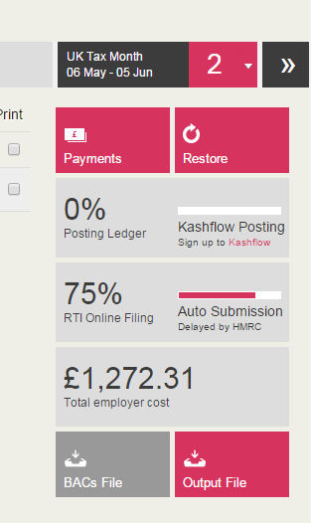

Once you have completed your payroll run, you can generate your output file from the finalised period screen;
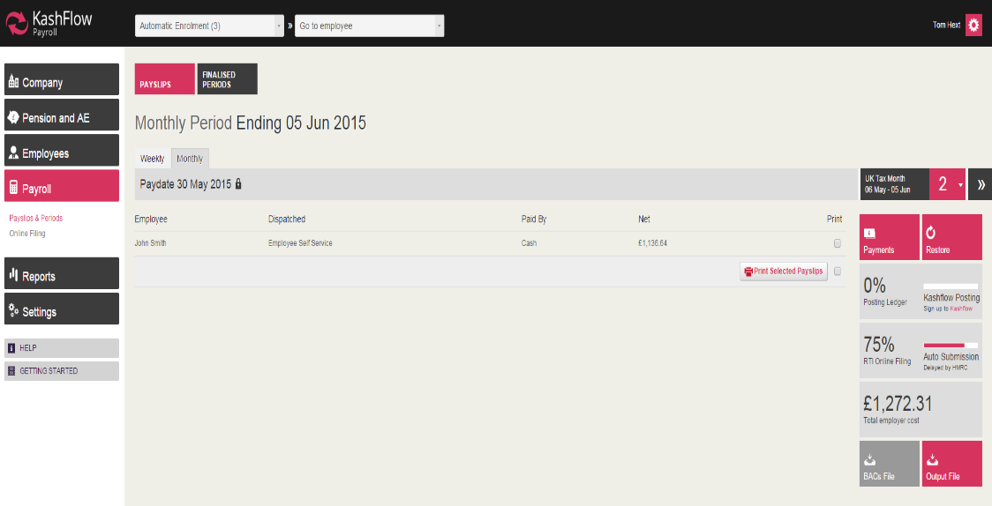
Within the finalised payroll screen, simply select the ‘Output File’ option to be taken to the next screen

Automatic Enrolment

You will then be shown a summary of the file to be uploaded and instructed to upload the file to your chosen pension provider. This must be done manually by the user and is not an automated process.
Your file(s) will then be downloaded sequentially and held in your ‘Downloads’ folder, or shown at the bottom of your screen depending upon your chosen browser.
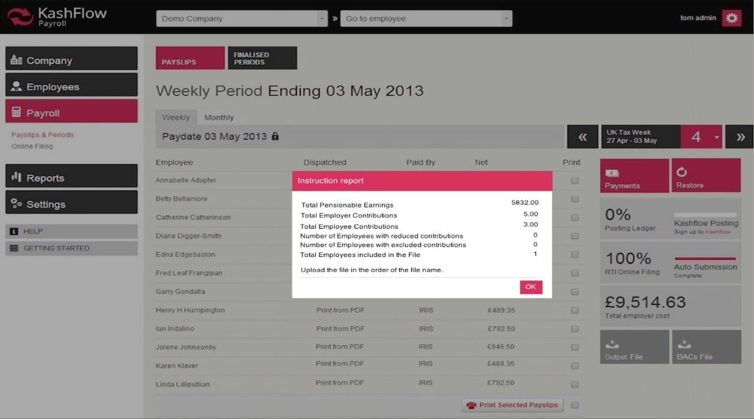

If you require any further information about Automatic Enrolment, please visit www.kashflow.com/autoenrolment to access a variety of guides, training courses and other resources to help you to prepare for and implement Automatic Enrolment using KashFlow Payroll.




Payroll Run

Now that you have a company with a weekly or monthly Pay Date and at least one employee, you can create a Payslip by clicking Payroll > Payslips & Periods.
When you click onto Payslips & Periods, KashFlow Payroll displays a list of employees who can be paid in the current pay period and shows you
- whether a payslip has been created
- the Net Pay on the Payslip, or
- that some more employee details are required before you can proceed
- Just click on an employee line to create a new Payslip or see the full Payslip.
Payslips
KashFlow Payroll lets you build the payslip on the screen by adding Items. When you click on the “new item” button in either the payments column or the deductions column, you will see an item picker. Use the picker navigation to choose appropriate payslip items to add.
Some items – like Tax and Statutory Sick Pay – are added automatically.
Items
When you pick an item KashFlow Payroll will set a default Value for you. For example, if the employee’s Hourly Rate is £10 and you select an hourly item such as Overtime then the Value will be £10. As you adjust the units up, say to 5 hours, the Value will reflect this and become £50.

You can change the text for any payslip item, but the following fields are available on some items only:
- Value – On most items you can override the calculated value.
- Repeat – Lets the item repeat automatically and stop at a specified End Period.
- Units – The number of hours, days or weeks.
- Times By – A multiplier to change the Value up or down. If you cannot find an item that exactly meets your needs just use the nearest one and change the appropriate settings.
Rates
An employee has an hourly, weekly and monthly Rate of pay that is set automatically from the items you enter on the payslip. For example, if an employee works 40 hours a week and you enter a weekly Wage of £400 then KashFlow Payroll sets the Hourly Rate to £10. You can edit the Rates if you like directly on the payslip.
Periods
You can switch to previous Periods (to see old payslips) or move to future Periods (to enter Items in advance) by using the handy Period Picker in the bar above the payslip.

Payroll Run

Approve
Click “Approve Payslip”, then “Save Changes” when you are happy with it – this prevents any Employee changes from affecting the payslip. For example, if you subsequently change the employee’s address, it won’t affect an approved payslip unless you explicitly refresh the data on that payslip.
Finalise Pay Date
When all the payslips have been approved you can finish the entire Pay Date by clicking “Finalise Week / Month” from the Payslips & Periods page.
If there are any problems with your payslips, KashFlow Payroll will warn you of before letting you finalise the Pay Date. Please note: once you have finalised a pay date, your RTI submissions will automatically be sent to HMRC. Payslips delivered electronically will be queued to send at the appropriate time.
RTI
When the Pay Date is locked KashFlow Payroll will submit all RTI returns automatically, without further user input. Use the Payroll > Online Filing screen to check the status of your RTI submissions.
KashFlow Payroll will submit an EPS automatically, but only if one is required and only after the end of the current Tax Month (but before the deadline on the 19th).

Paying HMRC
You are responsible for paying your employees their Net Pay and paying HMRC for the tax and NICs you have deducted on the payslips plus the employer NICs that you are liable for. You can go to the Company > Payments & Receipts to see how much is due to HMRC.
You should pay HMRC before the 19th of the next month.

Payroll Run

Advanced Editing
Click on any Item line on the payslip will automatically bringing up advanced information for that line item.
In this example, a ‘Time and Half Overtime’ Item brings up the following form:
Payslip Adv Item 1
- System Name shows the original name KashFlow Payroll provided for this item. This can be helpful if you have overtyped the item’s description.
- Start shows the payroll period on which the item started (or will start).
- End shows the payroll period on which the item ends.
- Government indicates whether or not the Item is Taxable and NIC’able
Note that the Start and End will always be the same period for items which do not (or cannot) repeat onto a future payslip.
Some Items let you change one or more of the following fields
- Amount – the actual amount for the payslip
- Units – for example ‘5 hours’ in the case of overtime
- Rate – the amount per unit used (for example £15.00 per hour)
- Times By – a multiple of the rate that alters the final Amount (1.5 in this Time and a Half example)

Repeating Items
When you add a repeating item – an item that can occur on future payslips – KashFlow Payroll automatically sets the item to repeat until the end of the following tax year. Notice that the advanced information form for a repeating line item changes to offer a drop down of periods to select from.
If you want to set a specific period in the future, simple click on the end period and choose a new one.
To end a repeating item on the payslip you’re currently working on, click the Icon that indicates that this item repeats.
The item will now show that it stops on the payslip you’re currently working on.

Payroll Run

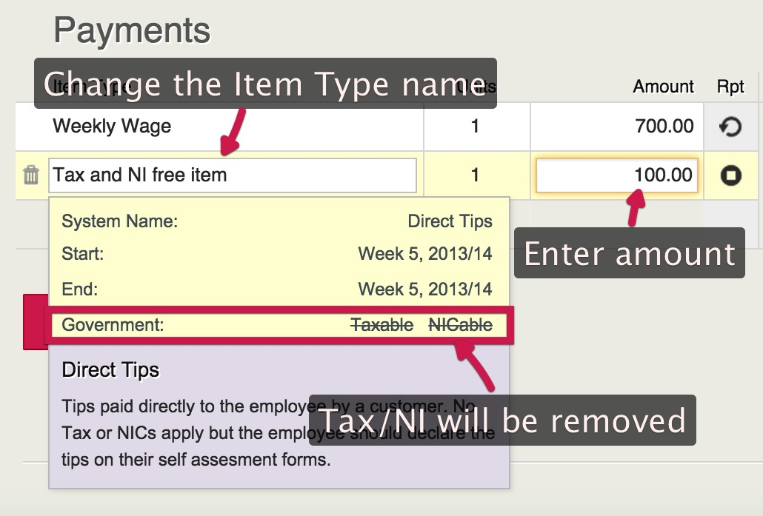
Tax and NI Deductions
At times an employee might have some amounts that are free from both TAX and NI.
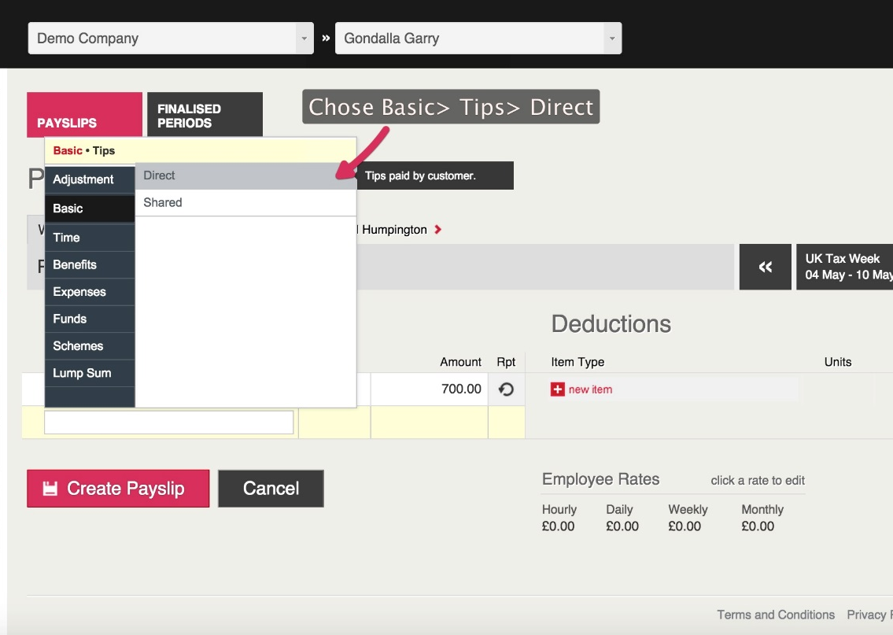
To show this on a KashFlow payroll payslip, click onto New Item > Basic > Tips > Direct > Change the name from direct tips to what you would like to appear on the payslip > Enter the amount. Once done, this amount will now not be included on the NI and TAX calculation of the payslip

Payroll Run

Statutory Leave (Holidays)
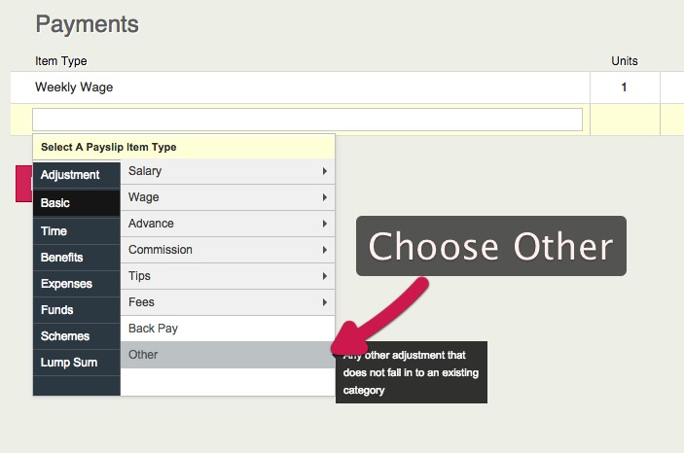
There is no code to record Statutory Leave in KashFlow Payroll, what you would need to do is click onto the payslip then Add new item> New item> Basic> Other. The name ‘Other Basic Pay’ will populate the field. You can overtype the text to show Holiday Pay.

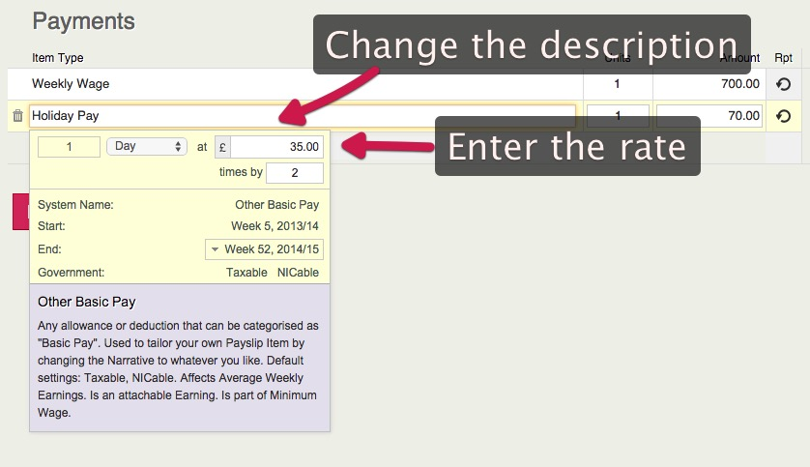

Payroll Run

Online Payslips
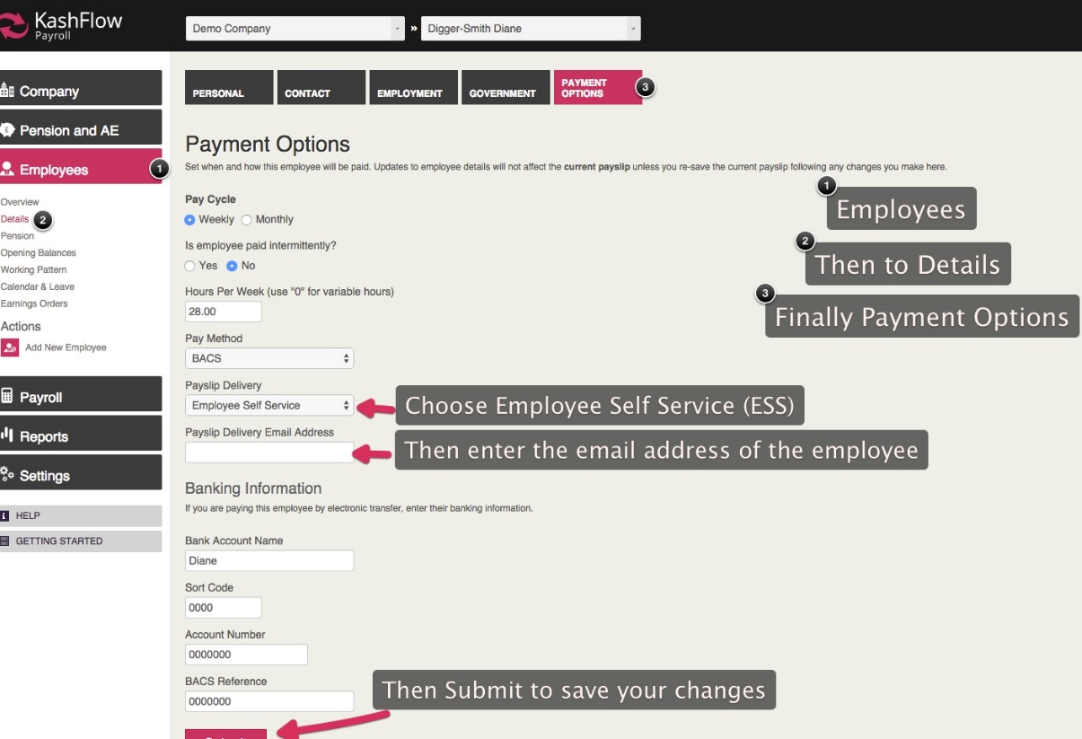
First you will need to navigate to your Employees details to enter to enable the feature as well as enter email address for the Payslip to be sent to. To start you will need to navigate to Employee> Details> Payment options. Once here choose Employee Self Service and enter the email address

Enabling Employee Self Service at the Employer level
Navigate to Company> Setup details> Payroll control> Enable ESS under Payslip Delivery Method
If employee claims that they have not received the e-mail. Check if the above is enabled and if all is as mentioned above, ask your employees to check their spam/junk folder just in case after re-checking their main mailbox inbox and also verify the e-mail address that has been provided and entered.
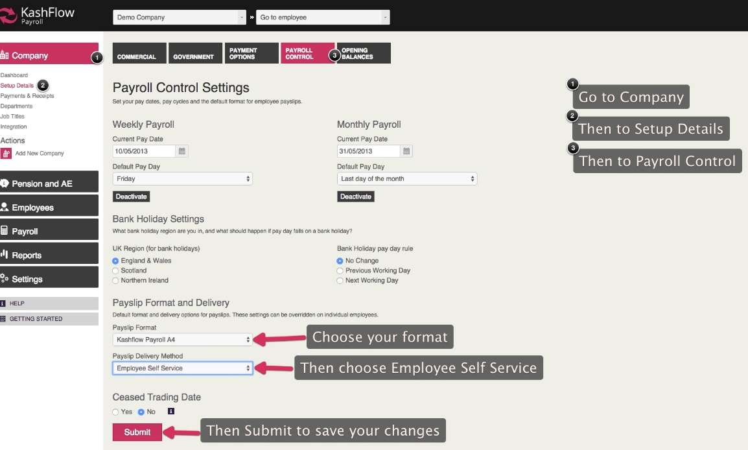
Still not received the email? Email the team on support@kashflowpayroll.com.
Payroll Run

Sending Payslips
Once you have completed your payroll run, as long as your initial ESS setup is complete, KashFlow Payroll will automatically generate and send the payslip to each employee
Confirmation of this will be shown once your payroll run has been finalised, on the finalised period(s) screen
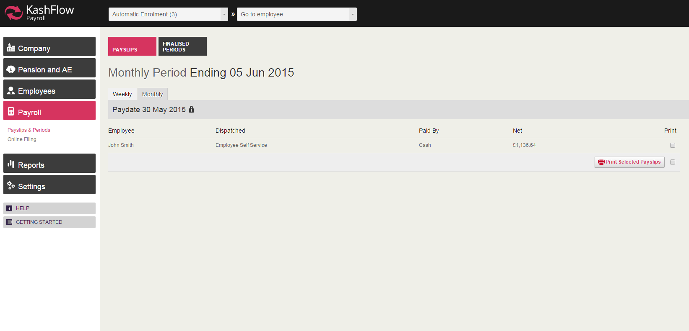

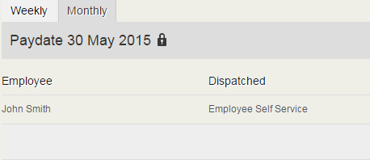

Reports

There are a number of reports contained within KashFlow Payroll to give you further analysis of your data including payroll run, employee details, pension and automatic enrolment reporting and statutory reports such as P45’s

Payroll Reports
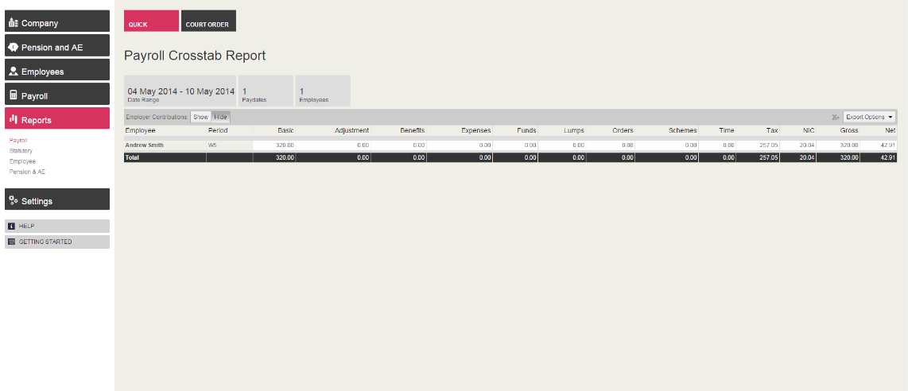
To access payroll reports, navigate to Reports on your main toolbar and Payroll. You can then select from either the Payslip Crosstab or Payslip by Items reports using the drop down menu
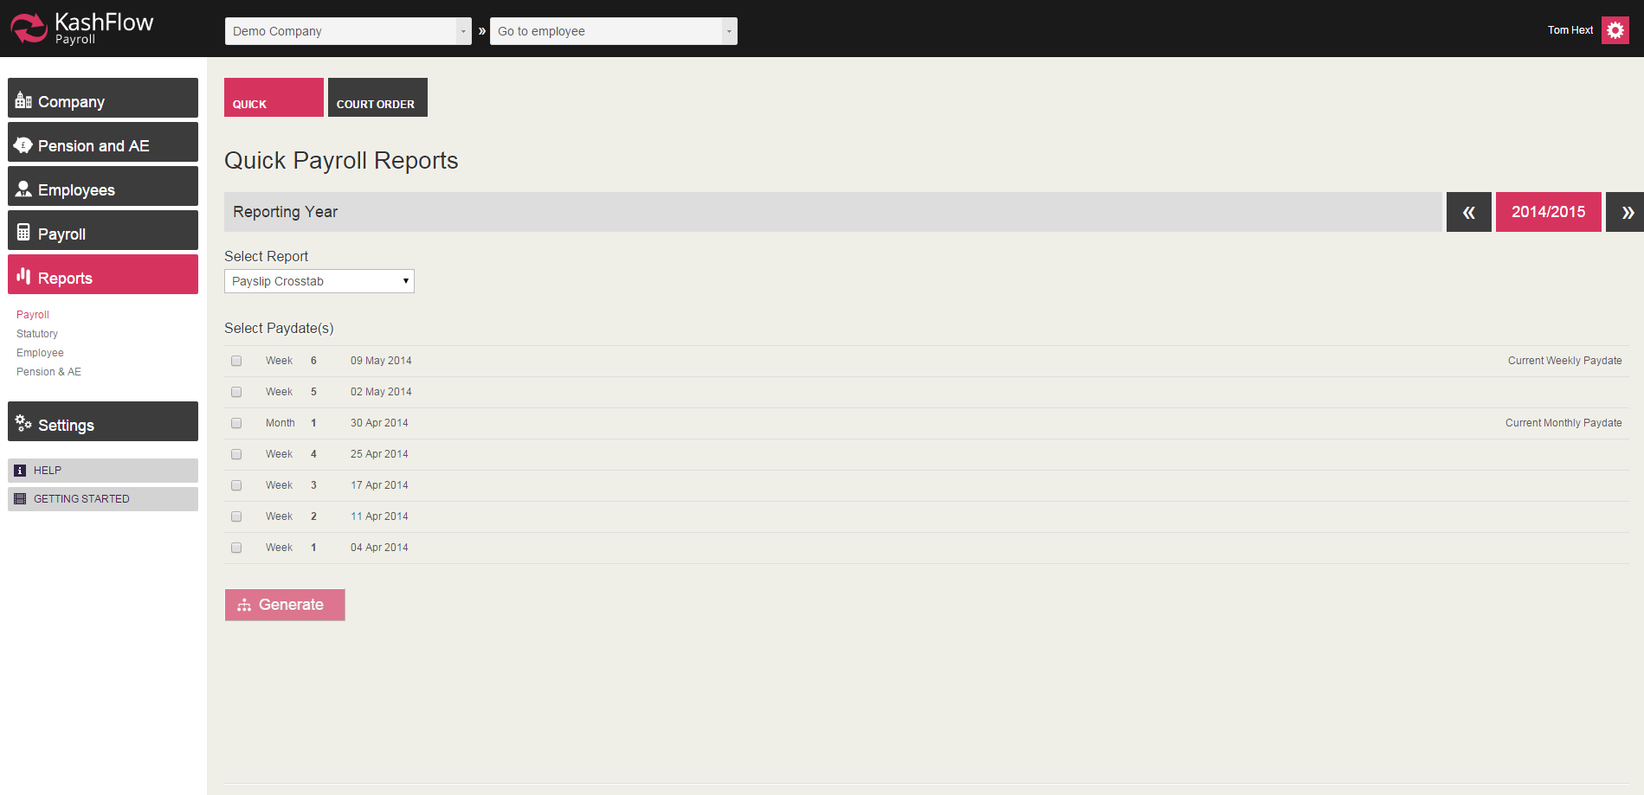

Payslip Crosstab
The payslip crosstab report is designed to show a breakdown of either your current, or a number of historical pay period for each employee, showing the different payslip items included on the payslips in that payroll run. You can select multiple pay periods within a single report using the tick boxes on the Payroll reports screen
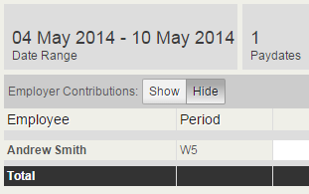
If you wish to show employer contributions for Tax/NI on your reports, simply use the Show/Hide option found at the top of each report

Reports

Payslip by Items
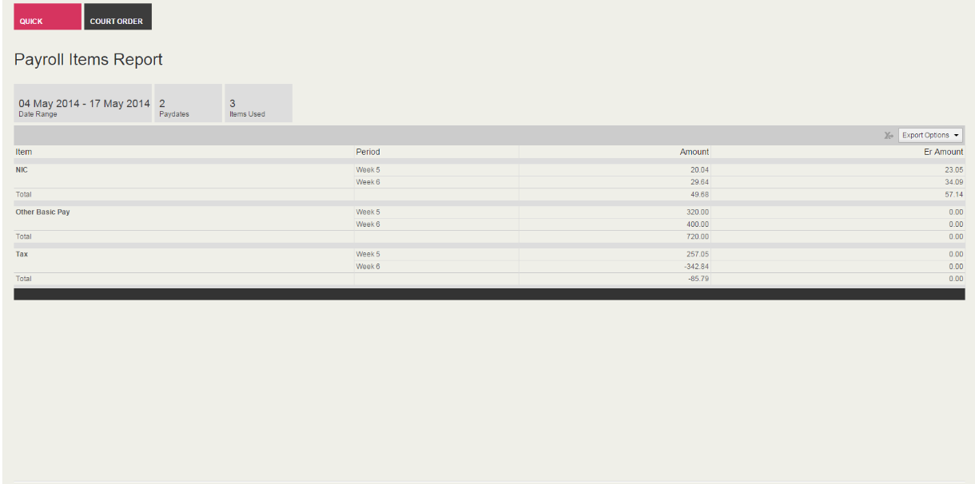
The payslips by items report will show a total amount across all employees within each particular pay item, including statutory payments

Court Order
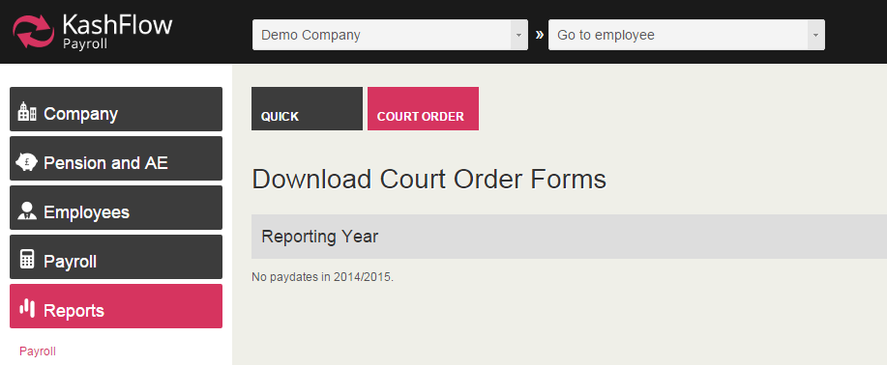
Selecting the Court Order tab will allow you to download court order forms required dependent upon information entered into your payroll run

Reports

Statutory Reports
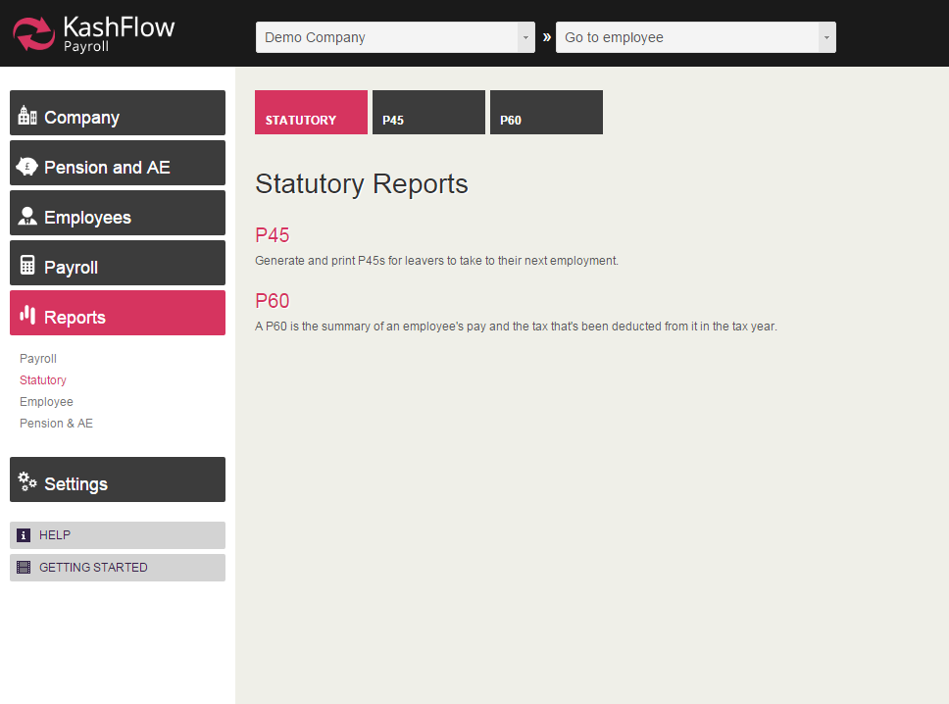
Selecting the Statutory Reports option will allow you to access P45 and P60 information for each employee.

P45

You must generate a P45 for each employee that leaves your employment. Information will automatically be entered into a P45 template for you, you simply need to export the report and print!

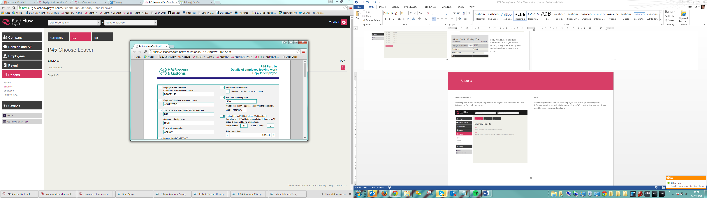

P60

You must generate a P60 at Year End for every employee within your employment in that year. This will only be possible once your Year End process has been finalised. For further information on the Year End process please visit the Knowledge Base

Reports

Employee Reports

You can generate a total of 4 employee reports using KashFlow. These include contact details, date details, authority details and pay details.

Contact Details

This report shows contact details for all current employees, or leavers within a selected date range

Date Details

This report will show length of service for all employees, current and leavers within a particular date range

Authority Details

This report will show tax and NI codes, plus NI information for all employees within a selected date period.

Pay Details

This report will show hourly rate, hours worked per week and pay method for each employees

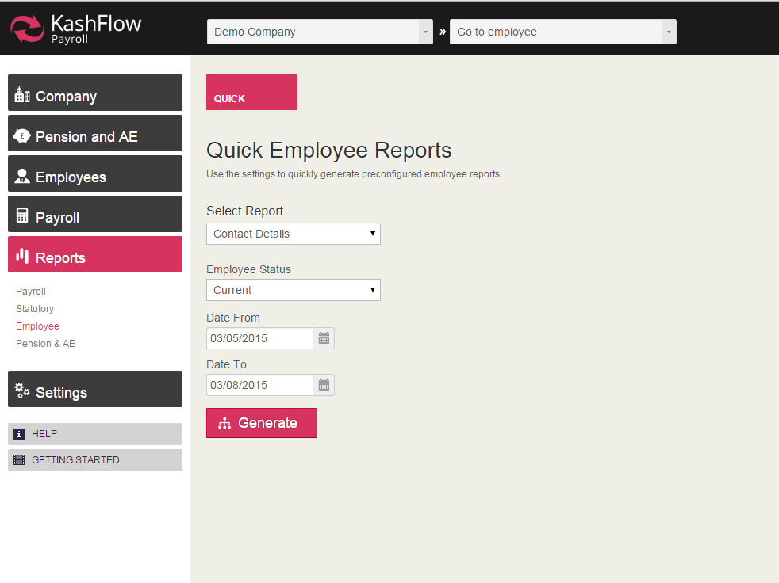

Reports

Pension Reports
To maintain visibility over your pension activity KashFlow Payroll has inserted a number of reports to allow you to report on your Automatic Enrolment activity each pay period
Pension Summary
The pension summary report will show total pensionable pay for the employee, including contribution this period, YTD contribution and YTD employer contribution for this employee
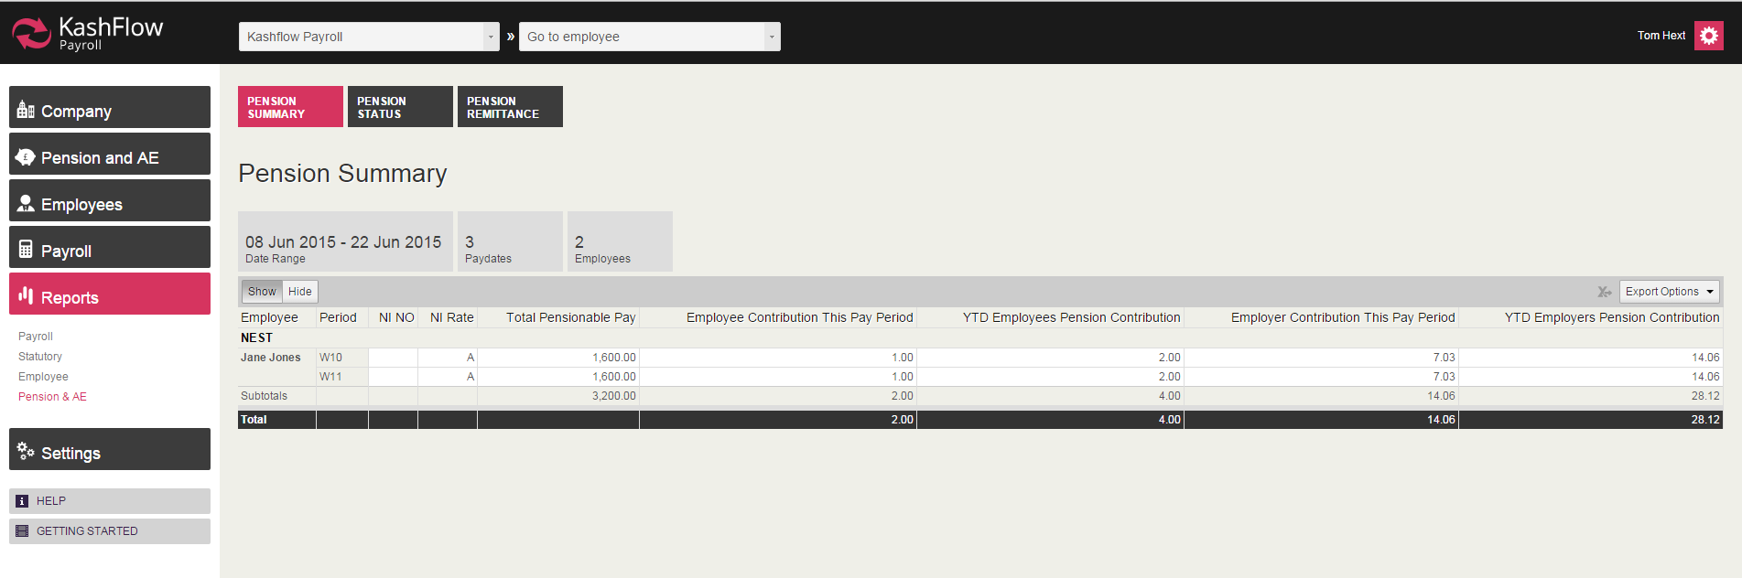

Pension Status
The pension status report will show the assessment status of each employee, whether they are an eligible, non-eligible or entitled employee under the legislation
Pension Remittance
The pension remittance report will show total pensionable pay and employee and employer contribution within a selected pay period

Please note you must create an output file to be sent to your pension provider and generate required communications with your employee as per the approved templates within KashFlow Payroll. Pension reports do not constitute legitimate communications to be sent to employees under the legislation

Thank you

Thank you for choosing KashFlow Payroll. If you require any further help please contact our Support team on support@kashflopayroll.com

For further information on Automatic Enrolment, including our range of training courses for small business owners and accountants please visit www.kashflow.com/autoenrolment

